BATCH No.

Rashtreeya Sikshana Samithi Trust
R.V. College of Engineering
(Autonomous Institution affiliated to VTU, Belagavi)
Department of Computer Science & Engineering
Bengaluru -560059



DIGITAL LOGIC DESIGN LAB
(16CS34)
III Semester B.E

LABORATORY RECORD
2017 – 2018

Name of the Student:_____________________________________

U S N :______________________________________

Semester : _____________ Section : ________________

R.V. College of Engineering
Bengaluru
(Autonomous Institution affiliated to VTU, Belagavi)
Department of Computer Science &
Engineering

Digital Logic Design
16CS34
Laboratory Record (Autonomous Scheme 2016)
R.V. College of Engineering, Bangalore - 59
(Autonomous Institution affiliated to VTU, Belagavi)
Department of Computer Science & Engineering

Laboratory Certificate

This is to certify that Mr. / Ms __________________________________
_____________________________has satisfactorily completed the course of Experiments in Practical____________________________________
Prescribed by the Department of Computer Science and Engineering during the year ______________________

Name of the Candidate: _______________________________________
USN No.: ___________________ Semester:_______________________

Marks
Maximum Obtained

Signature of the staff in-charge Head of the Department
Date:
Department of Computer Science and Engineering
R V College of Engineering, Bengaluru

Vision

To achieve leadership in the field of Computer Science & Engineering by strengthening fundamentals and facilitating interdisciplinary sustainable research to meet the ever growing needs of the society.

Mission

- To evolve continually as a center of excellence in quality education in computers and allied fields.
- To develop state-of-the-art infrastructure and create environment capable for interdisciplinary research and skill enhancement.
- To collaborate with industries and institutions at national and international levels to enhance research in emerging areas.
- To develop professionals having social concern to become leaders in top-notch industries and/or become entrepreneurs with good ethics.

Program Educational Objectives (PEOs):

PEO1: | Develop Graduates capable of applying the principles of mathematics, science, core engineering and Computer Science to solve real-world problems in interdisciplinary domains.
PEO2: | To develop the ability among graduates to analyze and understand current pedagogical techniques, industry accepted computing practices and state-of-art technology.
PEO3: | To develop graduates who will exhibit cultural awareness, teamwork with professional ethics, effective communication skills and appropriately apply knowledge of societal impacts of computing technology.
PEO4: | To prepare graduates with a capability to successfully get employed in the right role and achieve higher career goals or take-up higher education in pursuit of lifelong learning.

Program Outcomes (PO’s):

PO1: Engineering knowledge: Apply the knowledge of mathematics, science, engineering fundamentals, and an engineering specialization for the solution of complex engineering problems
PO2: Problem analysis: Identify, formulate, research literature, and analyze complex engineering problems reaching substantiated conclusions using first principles of mathematics, natural sciences and engineering sciences.
PO3: Design/development of solutions: Design solutions for complex engineering problems and design system components or processes that meet the specified needs with appropriate consideration for public health and safety, and cultural, societal, and environmental considerations.
PO4: Conduct investigations of complex problems: Design solutions for complex engineering problems and design system components or processes that meet the specified needs with appropriate consideration for public health and safety, and cultural, societal, and environmental considerations.
PO5: Modern tool usage: Create, select, and apply appropriate techniques, resources, and modern engineering and IT tools, including prediction and modeling to complex engineering activities, with an understanding of the limitations.
PO6: The engineer and society: Apply reasoning informed by the contextual knowledge to assess Societal, health, safety, legal, and cultural issues and the consequent responsibilities relevant to the professional engineering practice.
PO7: Environment and sustainability: Understand the impact of the professional engineering solutions in societal and environmental contexts, and demonstrate the knowledge of, and need for sustainable development.
PO8: Ethics: Apply ethical principles and commit to professional ethics and responsibilities and norms of the engineering practice.
PO9: Individual and team work: Function effectively as an individual, and as a member or leader in diverse teams, and in multidisciplinary settings.
PO10: Communication: Communicate effectively on complex engineering activities with the engineering community and with the society at large, such as, being able to comprehend and write effective reports and design documentation, make effective presentations, and give and receive clear instructions.
PO11: Project management and finance: Demonstrate knowledge and understanding of the engineering and management principles and apply these to one’s own work, as a member and leader in a team, to manage projects and in multidisciplinary environments.
PO12: Life-long learning: Recognize the need for, and have the preparation and ability to engage in independent and life-long learning in the broadest context of technological change.
Course Outcomes (Cos):

At the end of the course student will be able to

- Understand and explore the basic concepts of logic families, Boolean algebra, combinational and sequential circuits.
- Apply the concepts of simplification to realize the digital circuits.
- Analyze and evaluate different techniques to realize the digital circuits.
- Design and develop digital circuits for various applications.

Course Outcomes Vs Program Outcome
 | PO1 | PO2 | PO3 | PO4 | PO5 | PO6 | PO7 | PO8 | PO9 | PO10 | PO11 | PO12
CO1 | L | L | - | - | L | - | L | - | - | - | - | L
CO2 | M | M | - | - | L | - | L | - | M | M | - | L
CO3 | M | - | L | - | L | - | L | - | M | M | - | L
CO4 | - | L | M | - | L | - | M | - | M | L | - | L
Course Vs Program Outcome
COURSE | PO1 | PO2 | PO3 | PO4 | PO5 | PO6 | PO7 | PO8 | PO9 | PO10 | PO11 | PO12
COURSE | L | L | L | - | L | - | L | - | M | L | - | L

Do’s and Don’ts in the Laboratory

Do’s……………..
- Come Prepared to the lab.
- Use the computers and Logic controller kit for academic purposes only.
- Follow the lab exercise cycles as instructed by the department.
- Keep the chairs back to its position before you leave.
- Treat the trainer-kit with care.
- Keep your lab clean.
Don’ts……………..
- Do not handle any equipment before reading the Instructions/Instruction manuals.
- Read carefully the power ratings of the equipment before it is switched on whether ratings 230 V/50Hz or 115V/60 Hz. For Indian equipments, the power ratings are normally 230V/50Hz. If you have equipment with 115/60 Hz ratings, do not insert power plug, as our normal supply is 230V/50 Hz, which will damage the equipment.
- Observe type of sockets of equipment power to avoid mechanical damage.
- Do not forcefully place connectors to avoid the damage.
- Strictly observe the instructions given by the Teacher/Lab Instructor.

R.V COLLEGE OF ENGINEERING
(Autonomous Institution Affiliated to VTU)
Department of Computer Science, Bengaluru-59

Digital Logic Design Lab Rubrics (16CS34)

Lab Write-up and Execution rubrics (Max: 6 marks)
 |  |  | Excellent |  | Good | Poor | Marks
a. | Knowledge / Understanding  (2 Marks) |  | Demonstrates thorough ability in describing and illustrating the function of the circuit (2-1.5) |  | Demonstrates considerable ability in describing and illustrating the function of the circuit (1-0.5) | Unable to demonstrate, describe and illustrate the function of the Circuit (0)
b. | Circuit Construction  (2 Marks) |  | Excellent circuit functional, construction (2-1.5) |  | Fair circuit functional, construction (1-0.5) | Poor circuit functional, construction (0)
c. | Circuit Data Recording  (2 Marks) |  | Correct data input and excellent presentation (2-1.5) |  | Correct data input and fair presentation (1-0.5) | Correct data input and poor presentation (0)
Viva rubrics (Max: 4 marks)
 |  |  |  | Excellent | Good | Poor
a. |  | Circuit Data Analysis  (2 Marks) |  | Answers to data analysis questions, show complete understanding of how the circuit works (2-1.5) | Answers to data analysis questions, show solid understanding of how the circuit works (1) | Answers to data analysis questions, show no understanding of how the circuit works (0)
b. |  | Applications  (1 Mark) |  | Demonstrates a high ability when wiring logic gates to construct logical circuits (1) | Demonstrates considerable ability when wiring logic gates to construct logical circuits(0.5) | Demonstrates very limited ability when wiring logic gates to construct logic circuits (0)
c. |  | Communication of Ideas  (1 Mark) |  | Communicates all ideas clearly (1) | Communicates limited ideas (0.5) | Unable to communicate ideas(0)
Staff Signature Total

Digital Logic Design Code: 16CS34

List of Lab Experiments

Ex. No. | Description | CO’s | Page No.
1A  B. | Realization of Excess-3 Code converter with Parallel Adder and Subractor using IC – 7483.  Realization of Binary to Gray Code Converter and vice-versa using IC 74139.
2. | Realization of Full Adder and Full Subtractor using IC 74153.
3A.  B. | Design and realization One Bit and Two Bit Magnitude Comparator using Basic Gates.
4A.  B. | Realization of Decoder using IC – 7447.  Realization of Encoder using IC – 74147.
5. | Design and Realization of Master-Slave JK Flip Flop using NAND Gates only.
6A.  B. | Realization of Up-Down programmable counter using IC 74192 and IC 74193.  Realization of decade counter and its variations using IC 7490.
7A.  B. | Realization of Ring counter and Johnson counter using IC 7495.  Design and realization of sequence generator using IC 7495.
8. | Design of Mod-N Asynchronous Up and Down counter using IC 7476.
9. | Design of Mod-N Synchronous Up counter using IC 7476.

HDL (Verilog) programs using ModelSim

Write a Verilog code for 8:1 multiplexer, simulate and verify it’s working.
Write a Verilog code for a 4 bit comparator using logic gates, simulate and verify it’s working.
Write a Verilog for D Flip-Flop with positive-edge triggering, simulate and verify it’s working.
Write a Verilog code for a mod-8 up counter, simulate and verify it’s working.
Write a Verilog code for Mod-N Synchronous up-counter. Simulate and verify its truth table.
Write the Verilog description code for the given mealy model.

R.V. College of Engineering, Bengaluru - 59
(Autonomous Institution affiliated to VTU, Belagavi)
Department of Computer Science & Engineering
Particulars of the Experiments Performed

CONTENTS
CLASS: III SEMESTER CIE MARKS: (Max.): 50
YEAR: 2017-2018 SEE MARKS: (Max): 50
SUBJECT CODE: 16CS34 SEE: 3hrs
Sl. No | Date | Experiments | Page Nos. | Marks obtained  (Max Marks : 10) | Signature of Staff
1
2
3
4
5
6
7
8
9
HDL (Verilog) programs using ModelSim
1
2
3
4
5
6
TOTAL
Test

Introduction

This chapter is intended to introduce the student to some of the basic gates that will be used in the Digital logic design laboratory experiments. The content of this chapter includes the Pin diagram of basic gates. Following are the basic gates that are dealt in this chapter.

1. IC 7408: 2- input AND gate
2. IC 7400: 2-input NAND gate
3. IC 7486: X-OR gate
4. IC 7432: 2-input OR gate
5. IC 7404: NOT gate
6. IC 7402: 2-input NOR gate
7. IC744075:3-INPUT or gate
8. IC 7410: 3-input NAND gate
9. IC 7411: 3-input AND gate
10. IC 7420: dual 4-input NAND gate
11. IC 7421: dual 4-input AND gate
12. IC 74266: 2-input EX-NOR gate
13. IC 7490 : Decade Counter
14. IC 7411 : 3-input AND gate

All the above mentioned IC`s are known as small-scale integrated circuits which belongs to a logical family known as TTL.

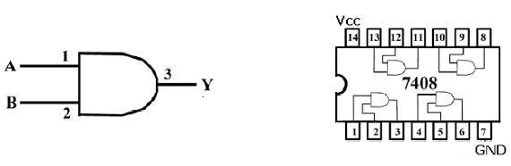
IC7408: Two Input AND Gate

Fig.1.1 (a) AND Gate Logic Symbol (b) Pin Diagram for the 7408 Quad AND

IC7411: Three Input AND Gate

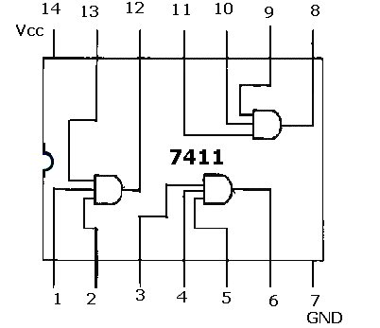

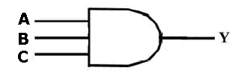

Fig.1.2(a) Logic Symbol for three input AND gate (b) Pin Diagram for the 7411 Triple 3 input AND gate

IC7432: Two Input OR Gate
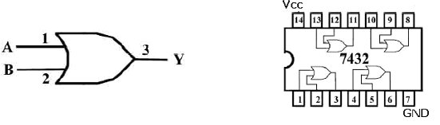

Fig.1.3 (a) OR Gate Logic Symbol (b) Pin Diagram for the 7432 Quad OR
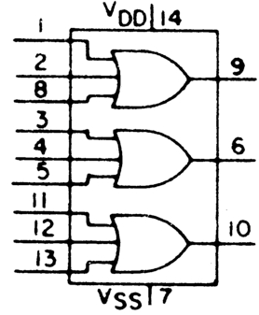
IC744075: Three Input OR Gate
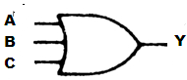

Fig.1.4 (a) OR Gate Logic Symbol (b) Pin Diagram of 744075 Triple three input OR

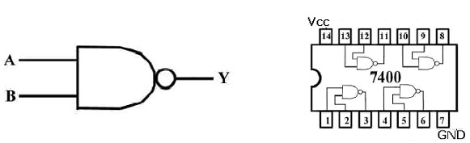
IC 7400: Two Input NAND Gate

Fig.1.5 (a) NAND Gate Logic Symbol (b) Pin Diagram for the 7400 Quad NAND

IC 7410: Three Input NAND Gate

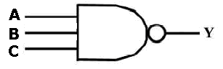
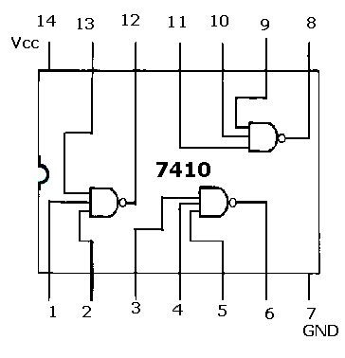

Fig.1.6 (a) Logic Symbol Of three input NAND gate (b) Pin Diagram for the 7410 Triple 3 input NAND gate

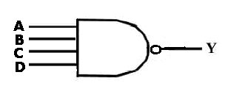
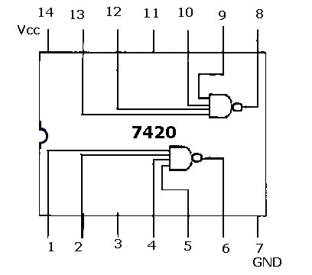
IC 7420: Four Input NAND Gate

Fig.1.7 (a) Logic Symbol Of four input NAND gate (b) Pin Diagram of 7420 Dual 4 input NAND gate

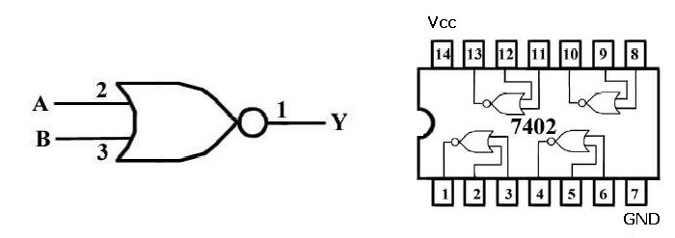
IC 7402: Two Input NOR Gate

Fig.1.8 (a) NOR Gate Logic Symbol (b) Pin Diagram for the 7402 Quad NOR

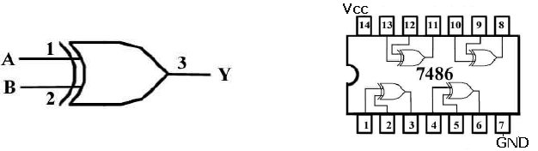
IC7486: Two Input EX-OR Gate

Fig.1.9 (a) X-OR Gate Logic Symbol (b) Pin Diagram for the 7486 Quad X-OR
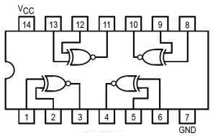
IC74266: Two Input EX-NOR Gate
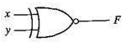

Fig.1.10 (a) EX-NOR Gate Logic Symbol (b) Pin Diagram for the 74266 Quad EX-NOR
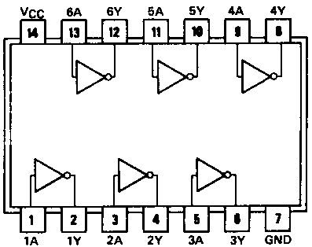

IC7404: Two Input NOT Gate
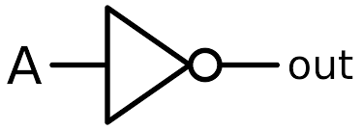

Fig: 1.11 Pin Diagram for the 7404 NOT Gate (b) Pin Diagram for the 7404 Inverter

Experiment 01

A. Realization of Excess-3 Code converter with Parallel Adder and Subractor using IC – 7483.

B. Realization of Binary to Gray Code Converter and vice-versa using IC 74139

A. Aim: To design Excess-3 Code converter using IC 7483parallel adder and verify the truth table
Components Required:

Sl. No. | Components | Specification | Quantity
1 | Parallel Adder | IC -7483 | 1 No
2 | 2 Input Ex-OR | IC 7486 | 1 No
3 | Digital trainer kit & patch cables | – | 1 No, 20 patch cables

Procedure: -

1. Verify the gates.
2. Make the connections as per the circuit diagram.
3. Connect to VCC and apply various combinations of input according to the truth table.
4. Note down the output readings for different combinations of inputs.
Theory:

The availability of large variety of codes for the same discrete elements of information results in the use of different codes by different systems. A conversion circuit must be inserted between the two systems if each uses different codes for same information. Thus, code converter is a circuit that makes the two systems compatible even though each uses different binary code.
Parallel adders are digital circuits that compute the addition of variable binary strings of equivalent or different size in parallel. The schematic diagram of a parallel adder is shown below, to add or subtract binary numbers. The circuit is laid out from right to left, similar to the way we add binary numbers. Therefore the least significant column is on the right, and the most significant column is on the left. The boxes labeled FA are full adders. The Carry out from each full adder is the carry in to the next higher full adder. The numbers being processed are A4 A3 A2 A1and B4 B3 B2 B1, while the answer is S4 S3 S2 S1. With 4-bit arithmetic, the final carry is ignored for reasons given earlier. With 8-bit arithmetic, the final carry is the carry into the addition of the upper bytes.

Binary Coded Decimal:
Binary Coded Decimal is a method of using binary digits to represent the decimal digits 0 through 9. It is possible to assign weights to the binary bits according to their positions. The weights in the BCD code are 8, 4, 2 and 1. Ex: (137)10 - BCD equivalent (0001 0011 0111)2.

Excess-3 Code:
This is an un-weighted code. Its code assignment is obtained from the corresponding value of BCD after the addition of (0011)2.

BCD to Excess-3 (or) Excess-3 to BCD:
Since each code uses four bits to represent a decimal digit, there must be four inputs and four output variables. The input variable are designated as B3, B2, B1, B0 and the output variables are designated as E3 , E2, E1, E0 in the truth table. Four binary variables have sixteen different input combinations, only ten of the input combinations are listed in the truth table. The six bit combinations not listed for the input variables are don’t care combination. The Boolean functions are obtained from K-Map for each output variable. The combinational logic for t h e code converters are designed according the Boolean expressions from K –Map simplification. The Boolean expressions from the K-Map are shown below. Each one of the four maps represents one of the four outputs of the circuit as a function of the four input variables. A two-level logic diagram may be obtained directly from the Boolean expressions derived by the maps. These are various other possibilities for a logic diagram that implements this circuit.

Circuit Diagram:
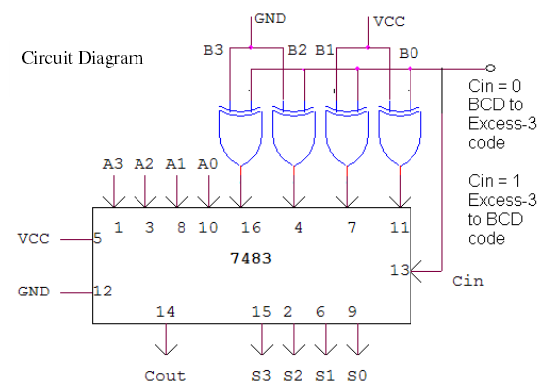
Truth Table:
i) BCD - EXCESS-3 CODE ii) Excess-3 – BCD CODE
EXCESS-3 |  |  |  | BCD
0 | 0 | 1 | 1
0 | 1 | 0 | 0
0 | 1 | 0 | 1
0 | 1 | 1 | 0
0 | 1 | 1 | 1
1 | 0 | 0 | 0
1 | 0 | 0 | 1
1 | 0 | 1 | 0
1 | 0 | 1 | 1
1 | 1 | 0 | 0

BCD |  |  |  | EXCESS-3
0 | 0 | 0 | 0
0 | 0 | 0 | 1
0 | 0 | 1 | 0
0 | 0 | 1 | 1
0 | 1 | 0 | 0
0 | 1 | 0 | 1
0 | 1 | 1 | 0
0 | 1 | 1 | 1
1 | 0 | 0 | 0
1 | 0 | 0 | 1

Inference:
B. Aim: Realization of Binary to Gray Code Converter and vice-versa using IC 74139

Components Required:

Sl. No. | Components | Specification | Quantity
1 | 2-to-4 line Decoder | 74139 | 1 No
2 | 4 Input NAND gate | 7420 | 1 No
3 | Digital trainer kit & patch cables | – | 1 No, 20 patch cables

Theory
IC 74139
This IC (common variants 74LS139, 74HC139) is a dual 2-to-4-line decoder in the 7400 series. Each side of the chip is a decoder with an active low enable from a 2-bit address to four active low signals. The two decoders can be wired independently, or a /Y from one decoders can be wired to the /E on the other to calculate more complex combinational logic functions. This IC can function as a dual 2 x 4 DEMUX also. It has active low enable pin 2 input/select lines and 4 output lines in each decoder. Unlike IC 74153 the input/select line are not internally shorted. If this IC is used to realize any digital circuits then the select lines along with enable line are used as data input.

Decoder as a De-multiplexer
IC 74139 can be used as a de-multiplexer by using input pins of the decoder as selection pin and the enable pin as the input pin. The principle behind this arrangement is that on applying an aggregated input combination on the input pins selects the corresponding output but respective logical level occurs at the output only if the enable pin is active. Thus if enable pin is active and based on the input combination output on the corresponding will below and if enable is high then output will be high as this IC is an active low output device.
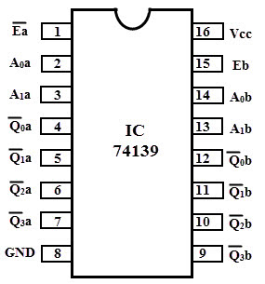

Procedure: -
1. Verified IC Number before conducting experiment
2. The IC is fixed into IC socket of the trainer kit and connect pin 16 to VCC and pin 8 to GND.
3. Connections are made as shown in logic diagram.
4. Connect all the inputs to switches and out to the LED’s
5. The inputs are applied using the toggle switches from the trainer kit according to the truth table and the corresponding outputs are verified on the LEDs.
6. Truth table is verified for different combination of input.

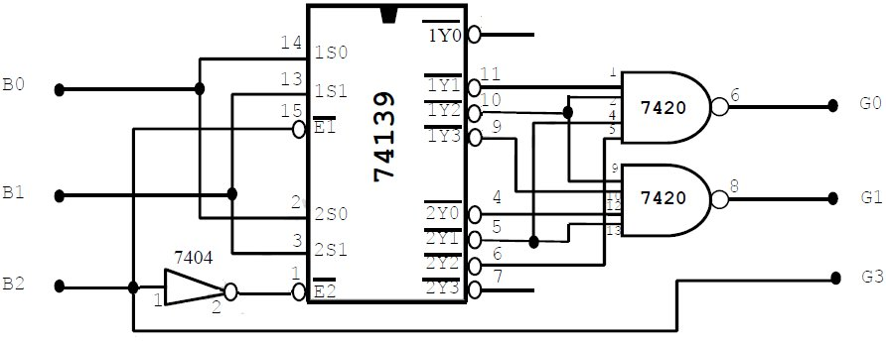
Circuit Diagram:

G0

G1

Truth Table: 3 Bit binary code conversion using IC74139
Inputs |  |  | Outputs
B2 | B1 | B0 | G2 | G1 | G0
0 | 0 | 0
0 | 0 | 1
0 | 1 | 0
0 | 1 | 1
1 | 0 | 0
1 | 0 | 1
1 | 1 | 0
1 | 1 | 1
G0 = B1B0
G1 = B2 B1
G2 = B2

G0 = ∑ m( )
G1 = ∑ m( )
G2 = ∑ m( )

Inference:

Lab Write-up and Execution rubrics (Max: 6 marks)
 |  |  | Excellent | Good | Poor | Marks
a. | Knowledge / Understanding  (2 Marks) |  | Demonstrates thorough ability in describing and illustrating the function of the circuit (2-1.5) | Demonstrates considerable ability in describing and illustrating the function of the circuit (1-0.5) | Unable to demonstrate, describe and illustrate the function of the Circuit (0)
b. | Circuit Construction  (2 Marks) |  | Excellent circuit functional, construction (2-1.5) | Fair circuit functional, construction (1-0.5) | Poor circuit functional, construction (0)
c. | Circuit Data Recording  (2 Marks) |  | Correct data input and excellent presentation (2-1.5) | Correct data input and fair presentation (1-0.5) | Correct data input and poor presentation (0)
Viva rubrics (Max: 4 marks)
 |  |  | Excellent | Good | Poor
a. |  | Circuit Data Analysis  (2 Marks) | Answers to data analysis questions, show complete understanding of how the circuit works (2-1.5) | Answers to data analysis questions, show solid understanding of how the circuit works (1) | Answers to data analysis questions, show no understanding of how the circuit works (0)
b. |  | Applications  (1 Mark) | Demonstrates a high ability when wiring logic gates to construct logical circuits (1) | Demonstrates considerable ability when wiring logic gates to construct logical circuits(0.5) | Demonstrates very limited ability when wiring logic gates to construct logic circuits (0)
c. |  | Communication of Ideas  (1 Mark) | Communicates all ideas clearly (1) | Communicates limited ideas (0.5) | Unable to communicate ideas(0)
Staff Signature Total

Experiment 02

Realization of Full Adder and Full Subtractor using IC 74153.

Aim: To Realize combinational circuit Full Adder using IC74153

Components Required:

Sl. No. | Components | Specification | Quantity
1 | Multiplexer | IC -74153 | 1 No
2 | NOT GATE | IC -7404 | 1No.
3 | Digital trainer kit & patch cables | – | 1 No, 20 patch cables

Theory
IC-74153 is a dual 4-to-1 multiplexer have 2 4:1 MUX name MUX A and MUX B this apart the IC has 2 select lines S0 and S1 for each of the MUX but these selection line are internally shorted together as show in the logic diagram below and hence the entire IC has only two selection pin. Each 4:1 MUX is associates with an active low enable pin namely E_{a} and E_{b}. With appropriated logic level on enable pins and on selection pins, logic levels on the input pin of any one or both the MUX can be transferred to the output. Z_{a} and Z_{b} are the output of MUX A and MUX B respectively.

74LS153 Dual 4-Input Multiplexer Pin Diagram IC 74153
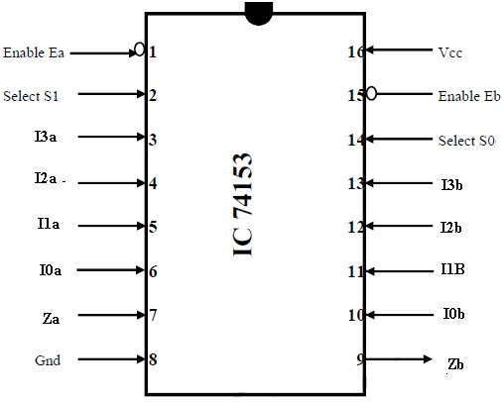
Logical Diagram
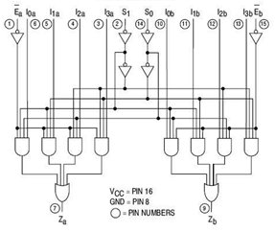

To realize any Boolean function with n input variable in an MUX have n-1 or n-2 selection pin we use either tabular method or Floyd method. Of these two methods tabular method is been used in this experiment to release Adder and Subtractor using 4:1 MUX. In case any Boolean function with n input variable need to be realized using MUX having n selection pin then it is just the matter of applying respective logic level on the inputs. This concept is exhibited in realization of half adder and half subtractor.

Truth table of Full adder:

Procedure:
Inputs |  |  | Outputs
A | B | C | Sum | Carry
0 | 0 | 0
0 | 0 | 1
0 | 1 | 0
0 | 1 | 1
1 | 0 | 0
1 | 0 | 1
1 | 1 | 0
1 | 1 | 1
Sum is realized on Max A, Carry realized on Mux B, both enable pins of the Muxare connecting Ea&Eb to logic 0 Connect A and B inputs to S1, S0 lines of Mux respectively according to input A and B different data inputs lines (I0 to I3) are selected connect the data inputs to logic 0 or logic 1 according to the required outputs. Express for sum and carry in terms input variables C
Logic Diagram
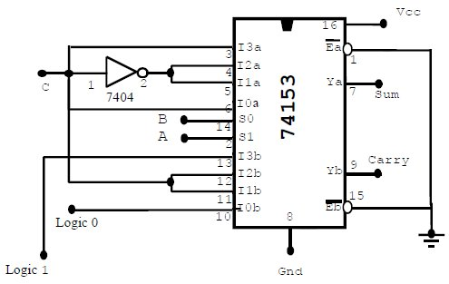

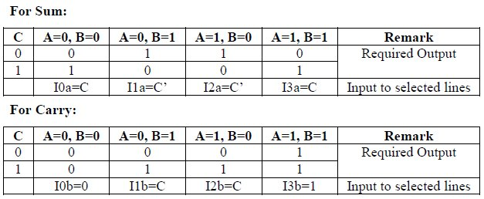

Procedure:
1. Verified IC Number before conducting experiment
2. The IC is fixed into IC socket of the trainer kit and connects VCC and GND.
3. Connections are made as shown in logic diagram.
4. Connect all the inputs to switches and out to the LED’s
5. The inputs are applied using the toggle switches from the trainer kit according to the truth table and the corresponding outputs are verified on the LEDs.
6. Truth table is verified for different combination of input.

Inference:

B. Aim: To Realize a Full Subtractor using IC74153
Components Required:

Sl. No. | Components | Specification | Quantity
1 | Multiplexer | IC -74153 | 1 No
2 | NOT GATE | IC -7404 | 1No.
3 | Digital trainer kit & patch cables | – | 1 No, 20 patch cables

Full Subtractor using 74153
Truth table of Full adder:

Procedure:
Inputs |  |  | Outputs
A | B | C | Diff | Borrow
0 | 0 | 0
0 | 0 | 1
0 | 1 | 0
0 | 1 | 1
1 | 0 | 0
1 | 0 | 1
1 | 1 | 0
1 | 1 | 1
Sum is realized on Max A, Carry realized on Mux B, both enable pins of the Muxare connecting Ea&Eb to logic 0 Connect A and B inputs to S1, S0 lines of Mux respectively according to input A and B different data inputs lines (I0 to I3) are selected connect the data inputs to logic 0 or logic 1 according to the required outputs. Express for sum and carry in terms input variables C

Logic Diagram:
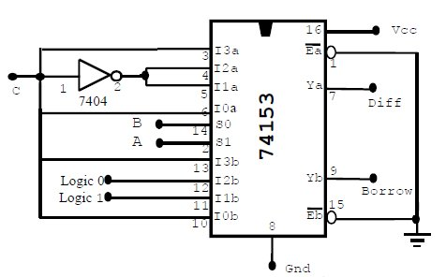

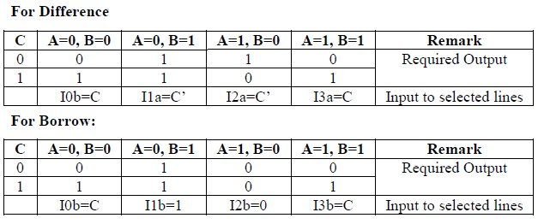

Procedure:
1. Verified IC Number before conducting experiment
2. The IC is fixed into IC socket of the trainer kit and connects VCC and GND.
3. Connections are made as shown in logic diagram.
4. Connect all the inputs to switches and out to the LED’s
5. The inputs are applied using the toggle switches from the trainer kit according
to the truth table and the corresponding outputs are verified on the LEDs.
6. Truth table is verified for different combination of input.

Inference:

Lab Write-up and Execution rubrics (Max: 6 marks)
 |  |  | Excellent | Good | Poor | Marks
a. | Knowledge / Understanding  (2 Marks) |  | Demonstrates thorough ability in describing and illustrating the function of the circuit (2-1.5) | Demonstrates considerable ability in describing and illustrating the function of the circuit (1-0.5) | Unable to demonstrate, describe and illustrate the function of the Circuit (0)
b. | Circuit Construction  (2 Marks) |  | Excellent circuit functional, construction (2-1.5) | Fair circuit functional, construction (1-0.5) | Poor circuit functional, construction (0)
c. | Circuit Data Recording  (2 Marks) |  | Correct data input and excellent presentation (2-1.5) | Correct data input and fair presentation (1-0.5) | Correct data input and poor presentation (0)
Viva rubrics (Max: 4 marks)
 |  |  | Excellent | Good | Poor
a. |  | Circuit Data Analysis  (2 Marks) | Answers to data analysis questions, show complete understanding of how the circuit works (2-1.5) | Answers to data analysis questions, show solid understanding of how the circuit works (1) | Answers to data analysis questions, show no understanding of how the circuit works (0)
b. |  | Applications  (1 Mark) | Demonstrates a high ability when wiring logic gates to construct logical circuits (1) | Demonstrates considerable ability when wiring logic gates to construct logical circuits(0.5) | Demonstrates very limited ability when wiring logic gates to construct logic circuits (0)
c. |  | Communication of Ideas  (1 Mark) | Communicates all ideas clearly (1) | Communicates limited ideas (0.5) | Unable to communicate ideas(0)
Staff Signature Total

Experiment 03

Design and Realization of One &Two Bit Magnitude Comparator using Basic Gates

A. Aim: To design one bit comparator, two bit comparator using logic gates

Components Required:

Sl. No. | Components | Specification | Quantity
1 | AND GATE | IC -7408 | 1 No
2 | NAND GATE | IC-7400 | 1 No.
3 | 3 Input NAND GATE | IC-7410 | 1 No.
4 | NOT GATE | IC -7404 | 1 No.
5 | XOR GATE | IC-7486 | 1 No.
6 | Digital trainer kit & patch cables | – | 1 No, 20 patch cables

Theory
One Bit Comparator
A magnitude comparator is a combinational circuit that compares two numbers A and B and determines their relative magnitude. The outcome of the comparison is specified by 3 binary variables that indicate whether A = B or A< B or A>B.

Truth table for one bit Comparator

Boolean Expression(A<B) =
Inputs |  | Outputs
A | B | A<B | A=B | A>B
0 | 0
0 | 1
1 | 0
1 | 1

Boolean Expression (A=B) =

Boolean Expression (A>B) =

K Map (A<B) K Map (A=B) K Map (A>B)
_{B}
0
0 1
0 1
0
1
B
A
0
1
_{A}
0
1

Logic Diagram of One Bit Comparator:

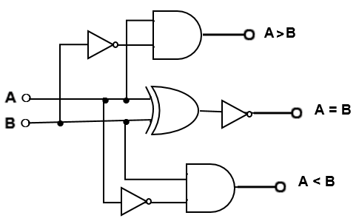

Two Bit Comparator
A magnitude comparator is a combinational circuit that compares four digital Bit A1, A0 and B1, B0 and determines their relative magnitude. The outcome of the comparison is specified by 3 binary variables that indicate whether A = B or A < B or A >B.

Truth table for Two bit Comparator
Observations:

Inputs |  |  |  | Outputs
A1 | A0 | B1 | B0 | A<B | A=B | A>B
0 | 0 | 0 | 0
0 | 0 | 0 | 1
0 | 0 | 1 | 0
0 | 0 | 1 | 1
0 | 1 | 0 | 0
0 | 1 | 0 | 1
0 | 1 | 1 | 0
0 | 1 | 1 | 1
1 | 0 | 0 | 0
1 | 0 | 0 | 1
1 | 0 | 1 | 0
1 | 0 | 1 | 1
1 | 1 | 0 | 0
1 | 1 | 0 | 1
1 | 1 | 1 | 0
1 | 1 | 1 | 1

K-Map for (A<B) Boolean Expression (A<B)
00 01 11 10
B1 B0
A1 A0
00
01
11
10

B1 B0
A1 A0
00
01
11
10

B1 B0 A1
A0
00
01
11
10

Boolean Expression (A=B)

K-Map for (A=B)

00 01 11 10

Boolean Expression (A>B)

K-Map for (A>B)
00 01 11 10

Logic diagram of two bit comparator:
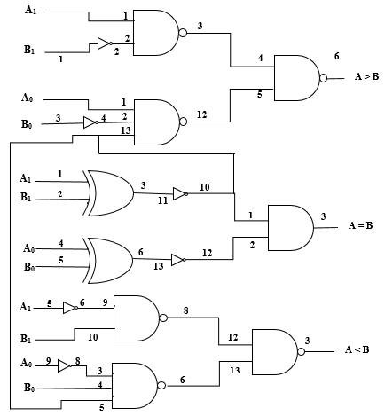

Procedure:
1. Verified IC Number before conducting experiment
2. The IC is fixed into IC socket of the trainer kit and connect VCC and GND.
3. Connections are made as shown in logic diagram.
4. Connect all the inputs to switches and out to the LED’s
5. The inputs are applied using the toggle switches from the trainer kit according to the truth table and the corresponding outputs are verified on the LEDs.
6. Truth table is verified for different combination of input.

Inference:

Lab Write-up and Execution rubrics (Max: 6 marks)
 |  |  | Excellent | Good | Poor | Marks
a. | Knowledge / Understanding  (2 Marks) |  | Demonstrates thorough ability in describing and illustrating the function of the circuit (2-1.5) | Demonstrates considerable ability in describing and illustrating the function of the circuit (1-0.5) | Unable to demonstrate, describe and illustrate the function of the Circuit (0)
b. | Circuit Construction  (2 Marks) |  | Excellent circuit functional, construction (2-1.5) | Fair circuit functional, construction (1-0.5) | Poor circuit functional, construction (0)
c. | Circuit Data Recording  (2 Marks) |  | Correct data input and excellent presentation (2-1.5) | Correct data input and fair presentation (1-0.5) | Correct data input and poor presentation (0)
Viva rubrics (Max: 4 marks)
 |  |  | Excellent | Good | Poor
a. |  | Circuit Data Analysis  (2 Marks) | Answers to data analysis questions, show complete understanding of how the circuit works (2-1.5) | Answers to data analysis questions, show solid understanding of how the circuit works (1) | Answers to data analysis questions, show no understanding of how the circuit works (0)
b. |  | Applications  (1 Mark) | Demonstrates a high ability when wiring logic gates to construct logical circuits (1) | Demonstrates considerable ability when wiring logic gates to construct logical circuits(0.5) | Demonstrates very limited ability when wiring logic gates to construct logic circuits (0)
c. |  | Communication of Ideas  (1 Mark) | Communicates all ideas clearly (1) | Communicates limited ideas (0.5) | Unable to communicate ideas(0)
Staff Signature Total

Experiment 04

A. Realization of Decoder using IC-7447
B. Realization of Encoder using IC-74147
A. Aim: To realize a Decoder using IC-7447

Components Required:

Sl. No. | Components | Specification | Quantity
1 | Decoder | IC -7447 | 1 No
2 | 7 Segment display LED |  | 1 No.
3 | Digital trainer kit & patch cables | – | 1 No, 20 patch cables

Theory:
74LS47 is a BCD to 7-segment decoder/driver IC. It accepts a binary coded decimal as input and converts it into a pattern to drive a seven-segment for displaying digits 0 to 9.
Binary coded decimal (BCD) is an encoding in which each digit of a number is represented by its own binary sequence (usually of four bits).
For example 239 in BCD is represented as 0010 0011 1001.

74LS47 IC accepts four lines of BCD (8421) input data and generates their complements internally. The data is decoded with seven AND/OR gates to drive indicator LEDs of the seven segment directly. The outputs correspond to Common anode (CA) configuration of seven segment.

The 74xx47 chip is used to drive 7 segment display. You must use the 74xx47 with a common anode 7-segment display (e.g. King bright part number SA03). The input to the 74xx47 is a binary number DCBA where D is 8s, C is 4s, B is 2s and A is 1s. The inputs DCBA often come from a binary counter.

The display is only sensible if the binary number is between DCBA=0000 (0) and DCBA=1001 (9); this is called Binary Coded Decimal or BCD for short. If the number is larger than 9 you get a strange output on the display. Try this out by moving your mouse over the truth table.
The inputs / , and (LAMP TEST)are usually connected to +5v.
Procedure
1. Connect V_{CC} [pin 16], [pin 3], / [pin 4] and [pin 5] to 5v.
2. Connect GND [pin 8] to 0v.
3. Connect DCBA [pins 1, 2, 6 and 7] to DCBA on your counter.
4. Connect [pins 9-15] to abcdefg on the common anode 7-segment display.
5. Apply BCD input on DCBA lines using toggle switches and observe the output on7-segment LED display unit

Pin Diagram IC 7447
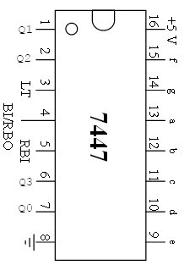

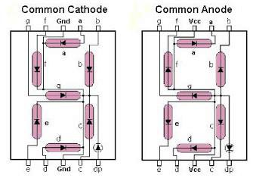

Using 7447 (Decoder) and seven segment decoder Logic diagram

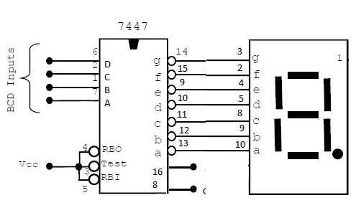

Truth Table:
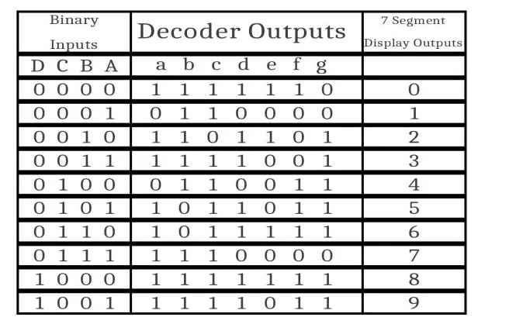

Procedure:
1. Verified IC Number before conducting experiment
2. The IC is fixed into IC socket of the trainer kit and connects VCC and GND.
3. Connections are made as shown in logic diagram.
4. Connect all the inputs to switches and out to the LED’s
5. The inputs are applied using the toggle switches from the trainer kit according to the truth table and the corresponding outputs are verified on the LEDs.
6. Truth table is verified for different combination of input.

Inference:

B. Aim: To realize an Encoder using IC 74147
Components Required:

Sl. No. | Components | Specification | Quantity
1 | Encoder | IC -74147 | 1 No
2 | Digital trainer kit & patch cables | – | 1 No, 20 patch cables

Theory:
IC 74147

The 74HC/HCT147 are high-speed Si-gate CMOS devices and are pin compatible with low power Schottky TTL (LSTTL). They are specified in compliance with JEDEC standard no. 7A. The 74HC/HCT147 9-input priority encoders accept data from nine active LOW inputs to A8) and provide a binary representation on the four active LOW outputs Y3). A priority is assigned to each input so that when two or more inputs are simultaneously active, the input with the highest priority is represented on the output, with input line A8 having the highest priority. The devices provide the to 4-line priority encoding function by use of the implied decimal "zero". The "zero" is encoded when all nine data inputs are HIGH, forcing all four outputs HIGH.

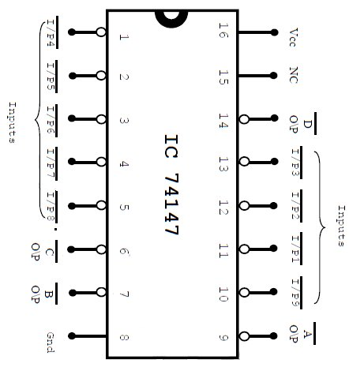
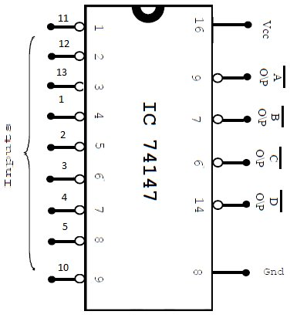
Pin Diagram Logic Diagram

Truth Table:

Active – Low Decimal Inputs |  |  |  |  |  |  |  |  | Active Low BCD Output
1 | 2 | 3 | 4 | 5 | 6 | 7 | 8 | 9 | D | C | B | A
1 | 1 | 1 | 1 | 1 | 1 | 1 | 1 | 1
0 | 1 | 1 | 1 | 1 | 1 | 1 | 1 | 1
X | 0 | 1 | 1 | 1 | 1 | 1 | 1 | 1
X | X | 0 | 1 | 1 | 1 | 1 | 1 | 1
X | X | X | 0 | 1 | 1 | 1 | 1 | 1
X | X | X | X | 0 | 1 | 1 | 1 | 1
X | X | X | X | X | 0 | 1 | 1 | 1
X | X | X | X | X | X | 0 | 1 | 1
X | X | X | X | X | X | X | 0 | 1
X | X | X | X | X | X | X | X | 0
X | X | X | X | X | X | X | X | X

Procedure:
1. Verified IC Number before conducting experiment
2. The IC is fixed into IC socket of the trainer kit and connect VCC and GND.
3. Connections are made as shown in logic diagram.
4. Connect all the inputs to switches and out to the LED’s
5. The inputs are applied using the toggle switches from the trainer kit according to the truth table and the corresponding outputs are verified on the LEDs.
6. Truth table is verified for different combination of input.

Inference:

Lab Write-up and Execution rubrics (Max: 6 marks)
 |  |  | Excellent | Good | Poor | Marks
a. | Knowledge / Understanding  (2 Marks) |  | Demonstrates thorough ability in describing and illustrating the function of the circuit (2-1.5) | Demonstrates considerable ability in describing and illustrating the function of the circuit (1-0.5) | Unable to demonstrate, describe and illustrate the function of the Circuit (0)
b. | Circuit Construction  (2 Marks) |  | Excellent circuit functional, construction (2-1.5) | Fair circuit functional, construction (1-0.5) | Poor circuit functional, construction (0)
c. | Circuit Data Recording  (2 Marks) |  | Correct data input and excellent presentation (2-1.5) | Correct data input and fair presentation (1-0.5) | Correct data input and poor presentation (0)
Viva rubrics (Max: 4 marks)
 |  |  | Excellent | Good | Poor
a. |  | Circuit Data Analysis  (2 Marks) | Answers to data analysis questions, show complete understanding of how the circuit works (2-1.5) | Answers to data analysis questions, show solid understanding of how the circuit works (1) | Answers to data analysis questions, show no understanding of how the circuit works (0)
b. |  | Applications  (1 Mark) | Demonstrates a high ability when wiring logic gates to construct logical circuits (1) | Demonstrates considerable ability when wiring logic gates to construct logical circuits(0.5) | Demonstrates very limited ability when wiring logic gates to construct logic circuits (0)
c. |  | Communication of Ideas  (1 Mark) | Communicates all ideas clearly (1) | Communicates limited ideas (0.5) | Unable to communicate ideas(0)
Staff Signature Total

Experiment 05

Realization of Master-Slave JK Flip-Flops using NAND IC7400

Aim: To realize Master-Slave JK Flip-Flops using NAND Gates and IC 7476

Components Required:
Sl. No. | Components | Specification | Quantity
1 | Flip-Lop | IC -7476 | 1 No
2 | NAND GATE | IC-7400 | 1 No
3 | 3 INPUT NAND GATE | IC-7410 | 2 No
4 | Digital trainer kit & patch cables | – | 1 No, 20 patch cables

Theory:
Flip-Flop
A flip-flop circuit can maintain a binary state indefinitely (as long as power is delivered to the circuit) until directed by an input signal to switch states. A flip-flop has two useful states, when Q=1 and Q’ = 0, it is in the set state (or 1-state). When Q = 0 and Q’ = 1, it is in the clear state (or 0-state). The outputs Q and Q’ are complements of each other and are referred to as the normal and complement outputs, respectively. The binary state of the flip-flop is taken to be the value of the normal output.

The NAND basic flip-flop circuit operates with both inputs normally at 1 unless the state of the flip-flop has to be changed. The application of a momentary 0 to the set input causes output Q to go to 1 and Q’ to go to 0, thus putting the flip-flop into the set state. After the set input returns to 1, a momentary 0 to the reset input causes a transition to the clear state. When both inputs go to 0, both outputs go to 1 – a condition avoided in normal flip-flop operation.

JK Flip-Flop
A JK flip-flop is a refinement of the RS flip-lop in that the indeterminate state of the RS type is defined in the JK type. Inputs J and K behave like inputs S and R to set and clear the flip-flop (note that in a JK flip-flop, the letter J is for set and the letter K is for clear). When inputs are applied to both J and K simultaneously, the flip-flop switches to its complement state, that is, if Q=1, it switches to Q=0, and vice versa.
Master – Slave Flip-flop:
A master – slave flip-flop is constructed from two separate flip-flops. One circuit serves as a master and the other as a slave, and the overall circuit is referred to as a master-slave flip -flop. It consists of a master flip-flop and a slave flip-flop. When clock pulse CP is 0, the output of the inverter is 1. Since the clock input of the slave is 1, the flip-flop is enabled and output Q is equal to Y, while Q’ is equal to Y’. The master flip flop is disabled because CP = 0. When the pulse becomes 1, the information then at the external R and S inputs is transmitted to the master flip-flop. The slave flip-flop, however, is isolated as long as the pulse is at its 1 level, because the output of the inverter is 0. When the pulse returns to 0, the master flip-flop is isolated, which prevents the external inputs from affecting it? The slave flip-flop then goes to the same state as the master flip-flop.
IC 7476 The 74LS76 is a Dual JK flip-flop IC, which contains two individual JK type bi-stable within a single chip enabling single or master-slave toggle flip-flops to be made.
JK types in this are negative-edge triggered flip-flop with both active low preset and clear inputs. Other JK flip-flop IC's include the 74LS107 Dual JK flip-flop with clear, the
74LS109 Dual positive-edge triggered JK flip-flop and the 74LS112 Dual negative-edge triggered flip-flop with both preset and clear inputs.
Pin Diagram
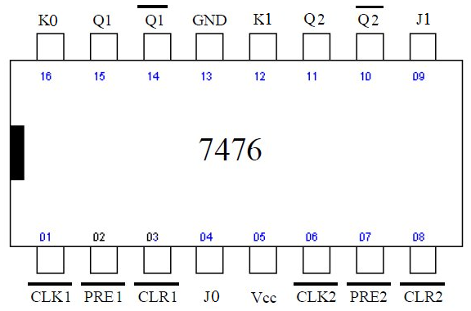

Procedure:
1. Rig up the circuit as shown in the figure
2. Keep both preset and reset/clear at logic high
3. Verify the truth table for JK Master-Slave

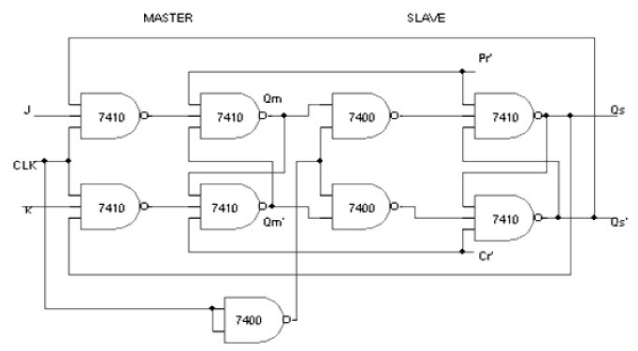
Logic Diagram of JK Master Slave using NAND Gate

Truth Table:
CLK | J | K | Qn+1(next state)
H | 0 | 0
H | 0 | 1
H | 1 | 0
H | 1 | 1

Inference:

Lab Write-up and Execution rubrics (Max: 6 marks)
 |  |  | Excellent | Good | Poor | Marks
a. | Knowledge / Understanding  (2 Marks) |  | Demonstrates thorough ability in describing and illustrating the function of the circuit (2-1.5) | Demonstrates considerable ability in describing and illustrating the function of the circuit (1-0.5) | Unable to demonstrate, describe and illustrate the function of the Circuit (0)
b. | Circuit Construction  (2 Marks) |  | Excellent circuit functional, construction (2-1.5) | Fair circuit functional, construction (1-0.5) | Poor circuit functional, construction (0)
c. | Circuit Data Recording  (2 Marks) |  | Correct data input and excellent presentation (2-1.5) | Correct data input and fair presentation (1-0.5) | Correct data input and poor presentation (0)
Viva rubrics (Max: 4 marks)
 |  |  | Excellent | Good | Poor
a. |  | Circuit Data Analysis  (2 Marks) | Answers to data analysis questions, show complete understanding of how the circuit works (2-1.5) | Answers to data analysis questions, show solid understanding of how the circuit works (1) | Answers to data analysis questions, show no understanding of how the circuit works (0)
b. |  | Applications  (1 Mark) | Demonstrates a high ability when wiring logic gates to construct logical circuits (1) | Demonstrates considerable ability when wiring logic gates to construct logical circuits(0.5) | Demonstrates very limited ability when wiring logic gates to construct logic circuits (0)
c. |  | Communication of Ideas  (1 Mark) | Communicates all ideas clearly (1) | Communicates limited ideas (0.5) | Unable to communicate ideas(0)
Staff Signature Total

Experiment 06

- Realization Up and Down Programmable Counter using IC74192 & IC74193

Aim: To Realization of counter usingIC74192 & IC74193
(i) Up / Down counter
(ii) Presettable Up counter
(iii) Presettable Down counter

Components Required:
Sl. No. | Components | Specification | Quantity
1 | COUNTER | IC -74192 | 1 No
2 | COUNTER | IC-74193 | 1 No
3 | NOT GATE | IC-7404 | 1 No
4 | 4 INPUT NAND GATE | IC-7420 | 1 No
5 | Digital trainer kit & patch cables | – | 1 No, 20 patch cables

IC74192:
The 74HC192; 74HCT192 is a 4-bit synchronous decade binary up/down counter.
Separate up/down clocks, ClkU and ClkD respectively, simplify operation. The outputs change state synchronously with the LOW-to-HIGH transition of either clock input. If the CLKU clock is pulsed while CLKD is held HIGH, the device will count up. If the CLKD clock is pulsed while CLKU is held HIGH, the device will count down. Only one clock input can be held HIGH at any time to guarantee predictable behavior. The device can be cleared at any time by the asynchronous master reset input (Clr); it may also be loaded in parallel by activating the asynchronous parallel load input. The terminal count up (Carry) and terminal countdown (Borrow) outputs are normally HIGH. When the circuit has reached the maximum count state of 09, the next HIGH-to-LOW transition of CLKU will cause carry to go LOW. Carry will stay LOW until CLKU goes HIGH again, duplicating the count up clock. Likewise, the Borrow output will go LOW when the circuit is in the zero state and the CLKD goes LOW. The terminal count outputs can be used as the clock input signals to the next higher order circuit in a multistage counter, since they duplicate the clock waveforms. Multistage counters will not be fully synchronous, since there is a slight delay time difference added for each stage that is added. The counter may be preset by the asynchronous parallel load capability of the circuit. Information present on the parallel data inputs (P0 to P3) is loaded into the counter and appears on the outputs (Q0 to Q3) regardless of the conditions of the clock inputs when the parallel load input is LOW. A HIGH level on the master reset input will disable the parallel load gates, override both clock inputs and set all outputs (Q0 to Q3) LOW. If one of the clock inputs is LOW during and after a reset or load operation, the next LOW-to-HIGH transition of that clock will be interpreted as a legitimate signal and will be counted. Inputs include clamp diodes. This enables the use of current limiting resistors to interface inputs to voltages in excess of VCC.

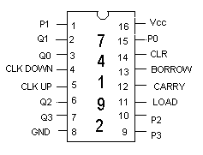
Pin Diagram

Pin Configuration
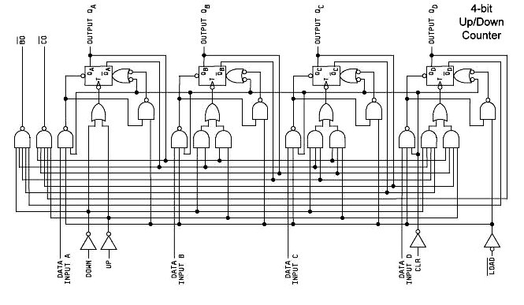

Truth Table
Load Clear
X 1
1 0
1 0
0 0
1 0

Mode
Clk–up
X
↑
1
X
1
Clk–down
X
1
↑
X
1
Preset to zero
Up – count
Down count
Preset
Stop count

Procedure Mod 10 Up & Down Counter: -
For up count clear the counter.
1. Clk-down=logic-1
2. Keep clear = logic-0 to clear the output, load can be maintained at either logic-0 or logic-1.
3. Then, first make Load=logic-1 and then Clear=logic-0, to start the counter.
4. Mono-pulses are applied at Clk-up.
5. Observe the count sequence at Q₃ Q₂ Q₁ Q₀.

For down count, clear the counter.
1. Clk-up=logic-1
2. Keep clear = 0, load = 0 to set the output.
3. Keep clear = 0 change load to 1, to start the counter.
4. Mono-pulses are applied at Clk-down.
5. Observe the count sequence at Q3 Q₂ Q₁ Q₀.

Preset table Mod 6 Up Counter
Circuit Diagram:
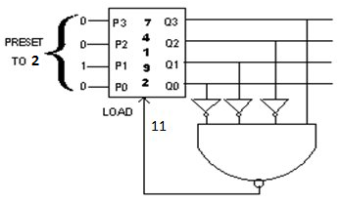

Procedure: -
To count from 2 to 7

1) Preset the data input to 0010.
2) Set Clk-down=logic-1
3) Set Clear=logic-0
4) Connect the load to the output of the NAND gate
5) Mono-pulses are applied at Clk-up
6) The o/p count should changes from 2 to 7, 2 to 7 & so on.

Preset table Mod 4 Down Counters:
Circuit Diagram:
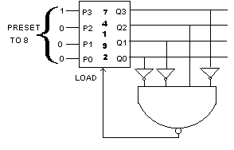

Procedure
1) Preset the data input to 1000.
2) Set Clk-up=logic-1
3) Set Load=logic-0 and Clear=logic-0
4) Connect the load to the output of the NAND gate
5) Mono-pulses are applied at Clk-down
6) The o/p count should changes from 8 to 5, 8 to 5 & so on.

Note: Students should also design Up – Down Synchronous Counter using Ic74193 74193 is a synchronous 4 bit binary up – counter which can be cleared and preset to any count

1) Pin details and functional table of 74193 is same as that of 74192
2) The procedure for both up and down counting as same as in 74192 except that 74193 counts 0, 1, 2 ----- 15 in up counting mode and 15, 14, 13 ------2, 1, 0 in down – counting mode
3) In up – counting mode carry goes low when Q₃ Q₂ Q₁ Q₀ changes from 1111 to 0000
4) In down – counting mode, borrow goes low when Q₃ Q₂ Q₁ Q₀ changes from 0000 to 1111

Inference:

B. Realization of decade counter and its variations using IC 7490.

Aim: To design and realize a decade counter using IC 7490.

Components Required:
Sl. No. | Components | Specification | Quantity
1 | BCD Counter | IC 7490 | 1 No
2 | 3-input t NAND gate | IC 7410 | 1 No
3 | Digital trainer kit & patch cables | – | 1 No, 20 patch cables
Procedure:
- Check all the components for their working.
- Insert the appropriate IC into the IC base.
- Make connections as shown in the circuit diagram.
- Verify the Truth Table and observe the outputs.

Circuit Diagram:
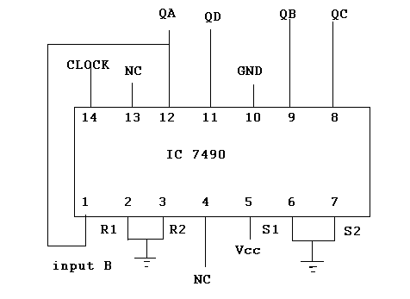

Truth Table:
Q_{D} | Q_{C} | Q_{B} | Q_{A}
0 | 0 | 0 | 0
Example 2:
7490 AS A DIVIDE BY N COUNTER (N=7):

Circuit Diagram:

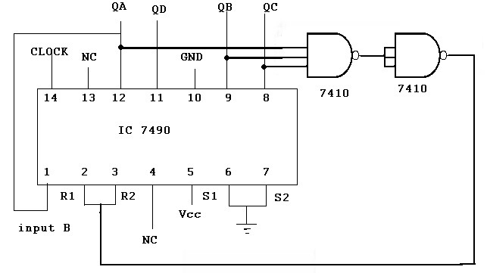

Truth Table:

Q_{D} | Q_{C} | Q_{B} | Q_{A}
0 | 0 | 0 | 0

Example 3: DIVIDE BY 5 COUNTERS:
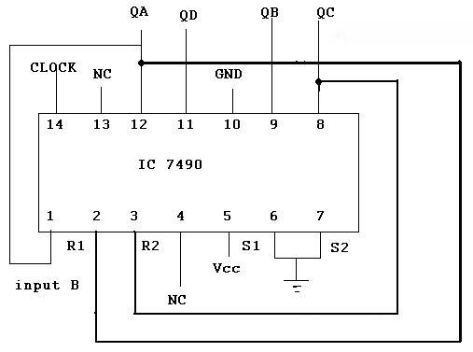

Truth Table:

Q_{D} | Q_{C} | Q_{B} | Q_{A}
0 | 0 | 0 | 0

Inference:

Lab Write-up and Execution rubrics (Max: 6 marks)
 |  |  | Excellent | Good | Poor | Marks
a. | Knowledge / Understanding  (2 Marks) |  | Demonstrates thorough ability in describing and illustrating the function of the circuit (2-1.5) | Demonstrates considerable ability in describing and illustrating the function of the circuit (1-0.5) | Unable to demonstrate, describe and illustrate the function of the Circuit (0)
b. | Circuit Construction  (2 Marks) |  | Excellent circuit functional, construction (2-1.5) | Fair circuit functional, construction (1-0.5) | Poor circuit functional, construction (0)
c. | Circuit Data Recording  (2 Marks) |  | Correct data input and excellent presentation (2-1.5) | Correct data input and fair presentation (1-0.5) | Correct data input and poor presentation (0)
Viva rubrics (Max: 4 marks)
 |  |  | Excellent | Good | Poor
a. |  | Circuit Data Analysis  (2 Marks) | Answers to data analysis questions, show complete understanding of how the circuit works (2-1.5) | Answers to data analysis questions, show solid understanding of how the circuit works (1) | Answers to data analysis questions, show no understanding of how the circuit works (0)
b. |  | Applications  (1 Mark) | Demonstrates a high ability when wiring logic gates to construct logical circuits (1) | Demonstrates considerable ability when wiring logic gates to construct logical circuits(0.5) | Demonstrates very limited ability when wiring logic gates to construct logic circuits (0)
c. |  | Communication of Ideas  (1 Mark) | Communicates all ideas clearly (1) | Communicates limited ideas (0.5) | Unable to communicate ideas(0)
Staff Signature Total

Experiment 07

A. Realization of Ring and Johnson Counter using IC7495

Components Required:

Sl. No. | Components | Specification | Quantity
1 | 4 BIT SHIT REGISTER | IC -7495 | 1 No
2 | NOT GATE | IC-7404 | 1 No
3 | Digital trainer kit & patch cables | – | 1 No, 20 patch cables

Theory:

a. Ring counter
A ring counter is a type of counter composed of a type circular shift register. The output of the last shift register is fed to the input of the first register. Ring counters are used in hardware logic design (e.g. ASIC & FPGA) to create simple finite state machines. A binary counter will require an adder circuit which is substantially more complex than a ring counter. Additionally, the worst case propagation delay on an adder circuit will be proportional to the number of bits in the code (due to the carry propagation). The propagation delay of a ring counter will be a constant regardless of the number of bits in the code. The complex combinational logic of an adder can create timing errors which may result in erratic hardware performance. Last, ring counters with Hamming distance 2(or more) allow the detection of single bit upsets that can occur in hazardous environments.
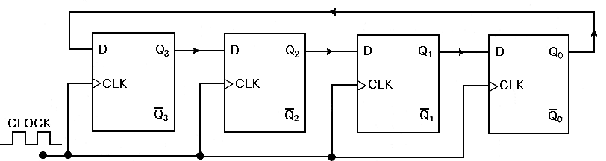

The disadvantage of ring counters is that they are lower density codes. A binary counter can represent 2^N states, where N is the number of bits in the code, whereas an Overbank counter can represent only N states and a Johnson counter can represent only 2N states. This may be an important consideration in hardware implementations where registers are more expensive than combinational logic.

b. JOHNSON COUNTER:
The Johnson Ring Counter or “Twisted Ring Counters”, is another shift register with feedback exactly the same as the standard Ring Counter above, except that this time the inverted output Q of the last flip-flop is now connected back to the input D of the first flip-flop as shown below.

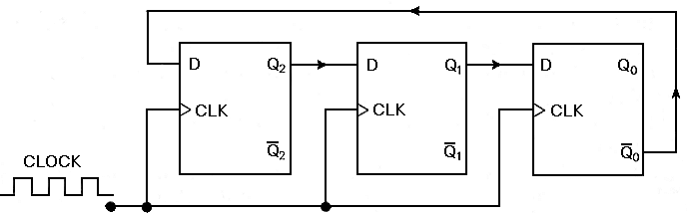

The main advantage of this type of ring counter is that it only needs half the number of flip-flops compared to the standard ring counter then it’s modulo number is halved. So a “n-stage” Johnson counter will circulate a single data bit giving sequence of 2n different states and can therefore be considered as a “mod-2n counter”.
Logic Diagram for Ring Counter:

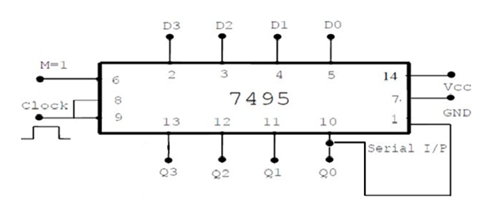

Truth Table:

Mode M | Clock | Inputs |  |  |  | Output
Mode M | Clock | D3 | D2 | D1 | D0 | Q3 | Q2 | Q1 | Q0
1 | 0 | 1 | 0 | 0 | 0
0 | 1
0 | 2
0 | 3
0 | 4
0 | 5

Procedures for Ring counter:

1. Connection is made as shown in the logic diagram.
2. 4 bit Data is loaded into shift registers D3, D2, D1 & D0.
3. Keeping Mode control M=1, clock pulse are applied, the data present in D3, D2, D1 & D0 will appear at Q3 , Q2, Q1 & Q0 respectively.
4. Keeping Mode control M=0, clock pulse are applied one by one and data arriving out serially at Q0 is observed.
5. Connect the output Q0 to Ds and keep applying clock pulses to realize ring counter.

Logic Diagram for Johnson Counter

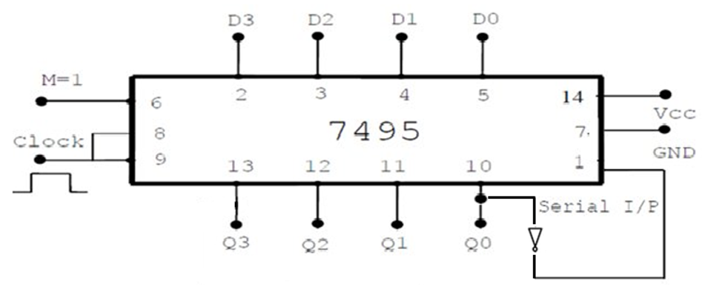
Truth Table:

Mode M | Clock | Inputs |  |  |  | Output
Mode M | Clock | D3 | D2 | D1 | D0 | Q3 | Q2 | Q1 | Q0
1 | 0 | 0 | 0 | 0 | 0
0 | 1
0 | 2
0 | 3
0 | 4
0 | 5
0 | 6
0 | 7
0 | 8

Procedure for Johnson Counter:

1. Connection is made as shown in the logic diagram.
2. 4 bit Data is loaded into shift registers D3, D2, D1 & D0.
3. Keeping Mode control M=1, clock pulse are applied, the data present in D3, D2, D1 & D0 will appear at Q3 , Q2, Q1 & Q0 respectively.
4. Keeping Mode control M=0, clock pulse are applied one by one and data arriving out serially at Q0 to Q3 is observed.
5. Connect the output Q0 to Ds through a NOT GATE and keep applying clockpulses to realize Johnson counter.

B. Realization of sequence generator using IC 7495

Aim: To design and realize a sequence generator using IC 7495

Components Required:

Sl. No. | Components | Specification | Quantity
1 | Shift Register | IC -7495 | 1 No
2 | Ex-OOR gate | IC-7486 | 1 No
3 | Digital trainer kit & patch cables | – | 1 No, 20 patch cables

Theory:

Procedure:
- Check all the components for their working.
- Insert the appropriate IC into the IC base.
- Make connections as shown in the circuit diagram.
- By Keeping mode=1. Load the input A,B,C,D as in Truth
- Table 1st Row and give a clock pulse
- For count mode make mode = 0.
- Verify the Truth Table and observe the outputs.
Example 1:
Sequence = 100010011010111
Sequence length S = 15

Circuit Diagram:

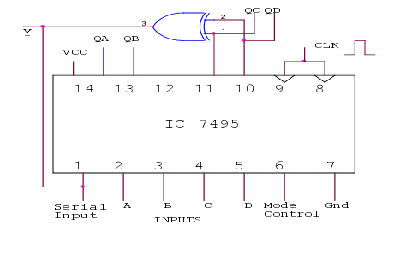

Truth Table:

Q_{A} | Q_{B} | Q_{C} | Q_{D} | Y= Q_{C} xor Q_{D}
1 | 1 | 1 | 1 | 0
0 | 1 | 1 | 1 | 0
0 | 0 | 1 | 1 | 0
0 | 0 | 0 | 1 | 1
1 | 0 | 0 | 0 | 0
0 | 1 | 0 | 0 | 0
0 | 0 | 1 | 0 | 1
1 | 0 | 0 | 1 | 1
1 | 1 | 0 | 0 | 0
0 | 1 | 1 | 0 | 0
1 | 0 | 1 | 1 | 0
0 | 1 | 0 | 1 | 1
1 | 0 | 1 | 0 | 1
1 | 1 | 0 | 1 | 1
1 | 1 | 1 | 0 | 1
 | 1 | 1 | 1
 |  | 1 | 1
 |  |  | 1

DESIGN 3:
Sequence = 1101011
Sequence length S = 7
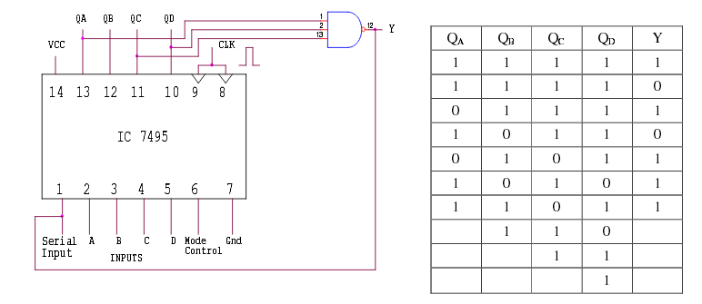

- Realization of decade counter and its variations using IC 7490.

Lab Write-up and Execution rubrics (Max: 6 marks)
 |  |  | Excellent | Good | Poor | Marks
a. | Knowledge / Understanding  (2 Marks) |  | Demonstrates thorough ability in describing and illustrating the function of the circuit (2-1.5) | Demonstrates considerable ability in describing and illustrating the function of the circuit (1-0.5) | Unable to demonstrate, describe and illustrate the function of the Circuit (0)
b. | Circuit Construction  (2 Marks) |  | Excellent circuit functional, construction (2-1.5) | Fair circuit functional, construction (1-0.5) | Poor circuit functional, construction (0)
c. | Circuit Data Recording  (2 Marks) |  | Correct data input and excellent presentation (2-1.5) | Correct data input and fair presentation (1-0.5) | Correct data input and poor presentation (0)
Viva rubrics (Max: 4 marks)
 |  |  | Excellent | Good | Poor
a. |  | Circuit Data Analysis  (2 Marks) | Answers to data analysis questions, show complete understanding of how the circuit works (2-1.5) | Answers to data analysis questions, show solid understanding of how the circuit works (1) | Answers to data analysis questions, show no understanding of how the circuit works (0)
b. |  | Applications  (1 Mark) | Demonstrates a high ability when wiring logic gates to construct logical circuits (1) | Demonstrates considerable ability when wiring logic gates to construct logical circuits(0.5) | Demonstrates very limited ability when wiring logic gates to construct logic circuits (0)
c. |  | Communication of Ideas  (1 Mark) | Communicates all ideas clearly (1) | Communicates limited ideas (0.5) | Unable to communicate ideas(0)
Staff Signature Total

Experiment 8

Mod-N Asynchronous Up and Down-Counters

Example 1:
Aim: -To design and implement mod-8 asynchronous up and down counter using JK flip-flop.

Components Required:

Sl. No. | Components | Specification | Quantity
1 | JK Flip Flop | IC -7476 | 2 No
2 | NAND GATE | IC-7400 | 1 No
3 | Digital trainer kit & patch cables | – | 1 No, 20 patch cables
Theory:
A counter is a digital sequential logic device that will go through a certain predefined states (for example counting up or down) based on the application of the input pulses. They are utilized in almost all computers and digital electronics systems. There are two main types of counters: Asynchronous and Synchronous counters.

Asynchronous counters
Definition: The counters in which the change in transition doesn’t depend upon the clock signal input is known as “Asynchronous counters”. In these counters, the first flip flop is connected to the external clock signal, and the rest are clocked by the state outputs (Q & Q’) of the previous flip flop.
Features:
- Another name for Asynchronous counters is “ Binary Ripple counters”.
- These are very simple in design.
- As its design is simple, they use less number of logic gates to construct an asynchronous counter.
- Operation of asynchronous counters is very slow compared to synchronous counters.

Synchronous counters
The counters which use clock signal to change their transition are called “Synchronous counters”. This means the synchronous counters depends on their clock input to change state values. All flip flops in the synchronous counters are triggered by same clock signal.
Features:
- Their construction is very simple in design. All the flip flops are interconnected and will be driven by same clock signal.
- The state output of the previous flip flop determines the state change of the present flip flop.
- As all the flip flops will work synchronously, the synchronous counters don’t require settling.
- We require number of logic gates to implement the synchronous counters.
- Their operation is fast.

Procedure:

- Verify the gates.
- Make the connections as per the circuit diagram.
- Apply mono pulse to the clock input.
- Note down the output readings for both the Up/Down counter and verify it using truth table.

Logic Diagram: 3-Bit Asynchronous Up Counter

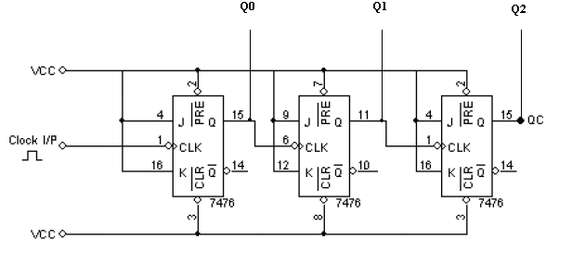
Connect 5-VCC
13- GND

Logic Diagram: 3-Bit Asynchronous Down Counter
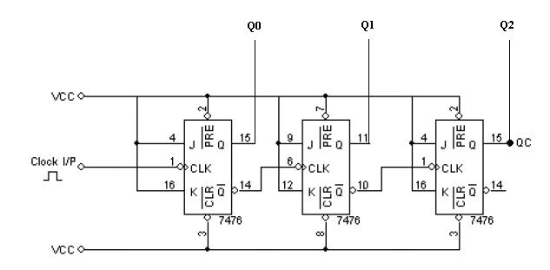
Connect 5-VCC
13- GND

Truth Table:

Up Counter (Up/Down(bar) = 1) |  |  |  | Down Counter (Up/Down(bar) = 0)
CLK | Q2 | Q1 | Q0 | CLK | Q2 | Q1 | Q0
------ | 0 | 0 | 0 | ------- | 1 | 1 | 1
1 |  |  |  | 1
2 |  |  |  | 2
3 |  |  |  | 3
4 |  |  |  | 4
5 |  |  |  | 5
6 |  |  |  | 6
7 |  |  |  | 7
8 |  |  |  | 8

Example 2:
Aim: Design MOD-5 asynchronous up counter using JK flip-flops.

Components Required:

Sl. No. | Components | Specification | Quantity
1 | J K Flip Flop | IC -7476 N | 2 No
2 | NAND GATE | IC-7400 | 1 No
3 | Digital trainer kit & patch cables | – | 1 No, 20 patch cables

Procedure: -

1. Verify the gates.
2. Make the connections as per the circuit diagram.
3. Connect to VCC and apply various combinations of input according to the truth table.
4. Apply mono pulse to the clock input and note down the output readings of mod-5 Up counter and verify it’s truth table.

Circuit Diagram:

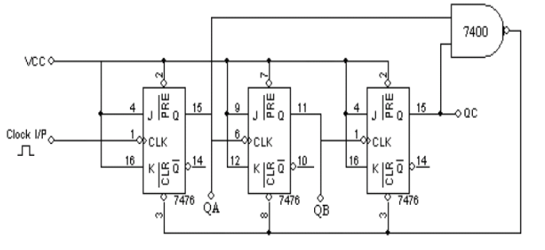
Connect 5-VCC
13- GND

Truth Table:

Clock Pulse | State
Clock Pulse | Q3 | Q2 | Q1
0 | 0 | 0 | 0
1
2
3
4
5

Inference:

Lab Write-up and Execution rubrics (Max: 6 marks)
 |  |  | Excellent | Good | Poor | Marks
a. | Knowledge / Understanding  (2 Marks) |  | Demonstrates thorough ability in describing and illustrating the function of the circuit (2-1.5) | Demonstrates considerable ability in describing and illustrating the function of the circuit (1-0.5) | Unable to demonstrate, describe and illustrate the function of the Circuit (0)
b. | Circuit Construction  (2 Marks) |  | Excellent circuit functional, construction (2-1.5) | Fair circuit functional, construction (1-0.5) | Poor circuit functional, construction (0)
c. | Circuit Data Recording  (2 Marks) |  | Correct data input and excellent presentation (2-1.5) | Correct data input and fair presentation (1-0.5) | Correct data input and poor presentation (0)
Viva rubrics (Max: 4 marks)
 |  |  | Excellent | Good | Poor
a. |  | Circuit Data Analysis  (2 Marks) | Answers to data analysis questions, show complete understanding of how the circuit works (2-1.5) | Answers to data analysis questions, show solid understanding of how the circuit works (1) | Answers to data analysis questions, show no understanding of how the circuit works (0)
b. |  | Applications  (1 Mark) | Demonstrates a high ability when wiring logic gates to construct logical circuits (1) | Demonstrates considerable ability when wiring logic gates to construct logical circuits(0.5) | Demonstrates very limited ability when wiring logic gates to construct logic circuits (0)
c. |  | Communication of Ideas  (1 Mark) | Communicates all ideas clearly (1) | Communicates limited ideas (0.5) | Unable to communicate ideas(0)
Staff Signature Total

Experiment 9

Mod-N Synchronous Up Counter

Aim: To design and test Mod-N (5, 6, 9, 10/decade) Synchronous Up counter using JK Flip Flop.

Components Required:

Sl. No. | Components | Specification | Quantity
1 | AND GATE | IC 7408 | 1 No
2 | OR GATE | IC 7432 | 1 No
3 | J K Flip Flop | IC -7476 N | 2 No
4 | Digital trainer kit & patch cables | – | 1 No, 20 patch cables

Example: Decade Counter
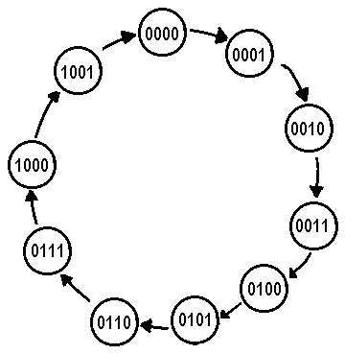
A synchronous decade counter will count from zero to nine and repeat the sequence. The state diagram of this counter is shown in Fig. 9.9.

Figure 9.9: State diagram of synchronous decade counter

Since there are ten states, four JK flip-flops are required. The truth tables of present and next state for the decade counter are shown in Fig. 9.10. Using the excitation table of JK flip-flop and the outputs of J and K are filled.

Procedure:

- Check all the components for their working.
- Insert the appropriate IC into the IC base.

- Make connections as shown in the circuit diagram.

- Verify the Truth Table and observe the outputs.
Truth Table:

Present State |  |  |  |  | Next State |  |  |  |  |  |  | Output
Q₃ | Q₂ | Q₁ | Q₀ | Q₃ |  | Q₂ | Q₁ | Q₀ | J₃ | K₃ | J₂ | K₂ | J₁ | K₁ | J₀ | K₀
0 | 0 | 0 | 0 | 0 |  | 0 | 0 | 1 | 0 | X | 0 | X | 0 | X | 1 | X
0 | 0 | 0 | 1 | 0 |  | 0 | 1 | 0 | 0 | X | 0 | X | 1 | X | X | 1
0 | 0 | 1 | 0 | 0 |  | 0 | 1 | 1 | 0 | X | 0 | X | X | 0 | 1 | X
0 | 0 | 1 | 1 | 0 |  | 1 | 0 | 0 | 0 | X | 1 | X | X | 1 | X | 1
0 | 1 | 0 | 0 | 0 |  | 1 | 0 | 1 | 0 | X | X | 0 | 0 | X | 1 | X
0 | 1 | 0 | 1 | 0 |  | 1 | 1 | 0 | 0 | X | X | 0 | 1 | X | X | 1
0 | 1 | 1 | 0 | 0 |  | 1 | 1 | 1 | 0 | X | X | 0 | X | 0 | 1 | X
0 | 1 | 1 | 1 | 1 |  | 0 | 0 | 0 | 1 | X | X | 1 | X | 1 | X | 1
1 | 0 | 0 | 0 | 1 |  | 0 | 0 | 1 | X | 0 | 0 | X | 0 | X | 1 | X
1 | 0 | 0 | 1 | 0 |  | 0 | 0 | 0 | X | 1 | 0 | X | 0 | X | X | 1

The Karnaugh maps of the output J₀, K₀, J₁, K₁, J₂, K₂, J₃, and K₃ are shown below:
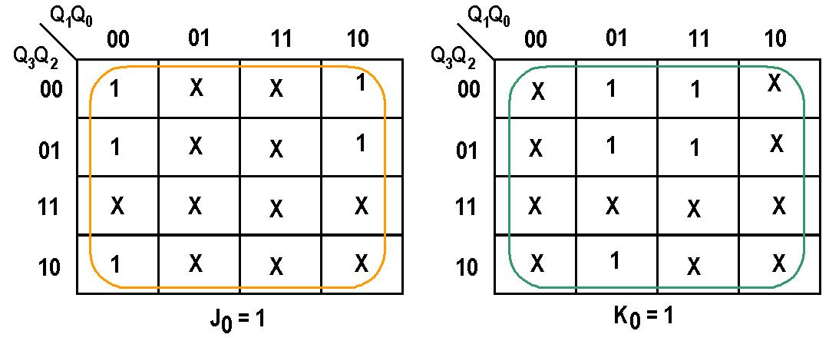

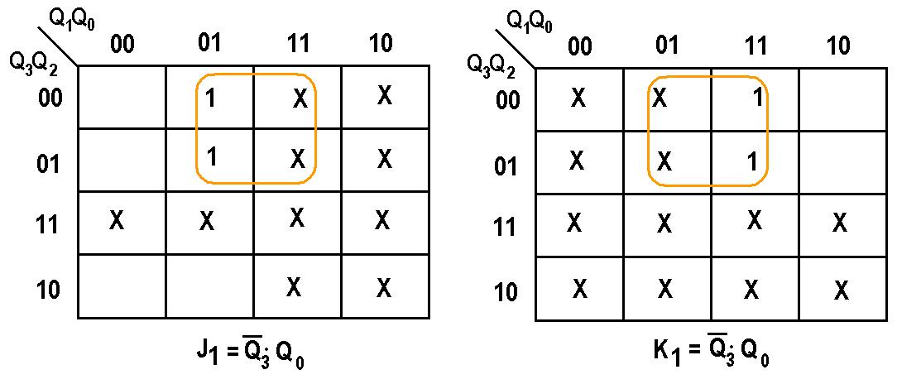

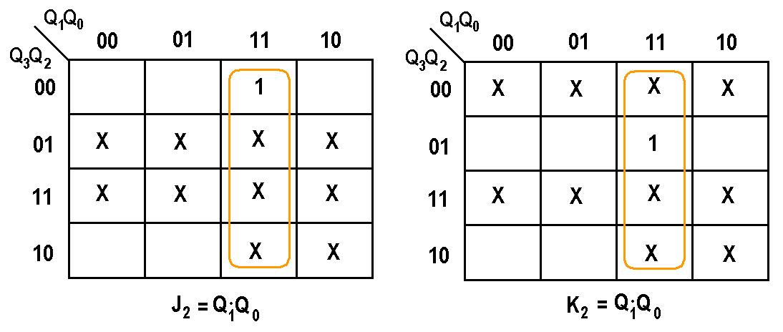

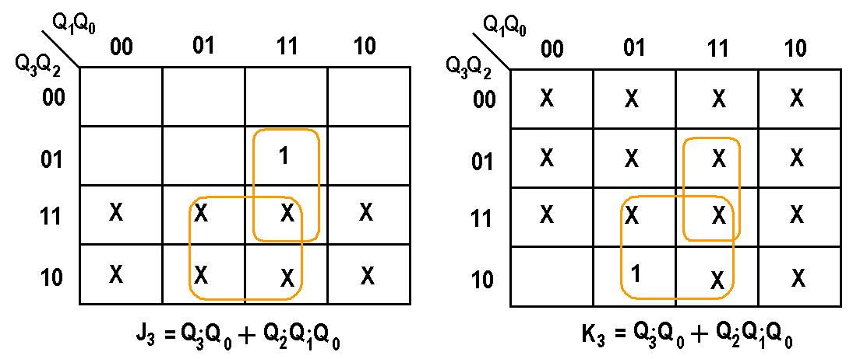

Logic Diagram:
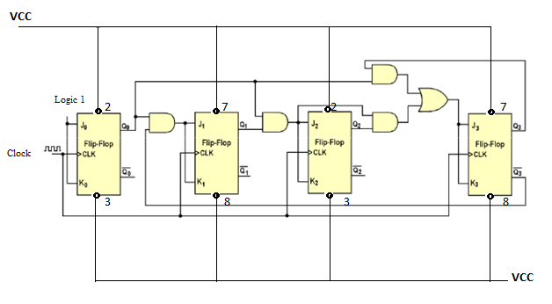

Inference:

Lab Write-up and Execution rubrics (Max: 6 marks)
 |  |  | Excellent | Good | Poor | Marks
a. | Knowledge / Understanding  (2 Marks) |  | Demonstrates thorough ability in describing and illustrating the function of the circuit (2-1.5) | Demonstrates considerable ability in describing and illustrating the function of the circuit (1-0.5) | Unable to demonstrate, describe and illustrate the function of the Circuit (0)
b. | Circuit Construction  (2 Marks) |  | Excellent circuit functional, construction (2-1.5) | Fair circuit functional, construction (1-0.5) | Poor circuit functional, construction (0)
c. | Circuit Data Recording  (2 Marks) |  | Correct data input and excellent presentation (2-1.5) | Correct data input and fair presentation (1-0.5) | Correct data input and poor presentation (0)
Viva rubrics (Max: 4 marks)
 |  |  | Excellent | Good | Poor
a. |  | Circuit Data Analysis  (2 Marks) | Answers to data analysis questions, show complete understanding of how the circuit works (2-1.5) | Answers to data analysis questions, show solid understanding of how the circuit works (1) | Answers to data analysis questions, show no understanding of how the circuit works (0)
b. |  | Applications  (1 Mark) | Demonstrates a high ability when wiring logic gates to construct logical circuits (1) | Demonstrates considerable ability when wiring logic gates to construct logical circuits(0.5) | Demonstrates very limited ability when wiring logic gates to construct logic circuits (0)
c. |  | Communication of Ideas  (1 Mark) | Communicates all ideas clearly (1) | Communicates limited ideas (0.5) | Unable to communicate ideas(0)
Staff Signature Total

HDL (Verilog) programs using ModelSim
About ModelSim:
Designers of digital systems are inevitably faced with the task of testing their designs. Each design can be composed of many modules, each of which has to be tested in isolation and then integrated into a design when it operates correctly.
To verify that a design operates correctly we use simulation, which is a process of testing the design by applying inputs to a circuit and observing its behavior. The output of a simulation is a set of waveforms that show how a circuit behaves based on a given sequence of inputs. The general flow of a simulation is shown in the below figure.

*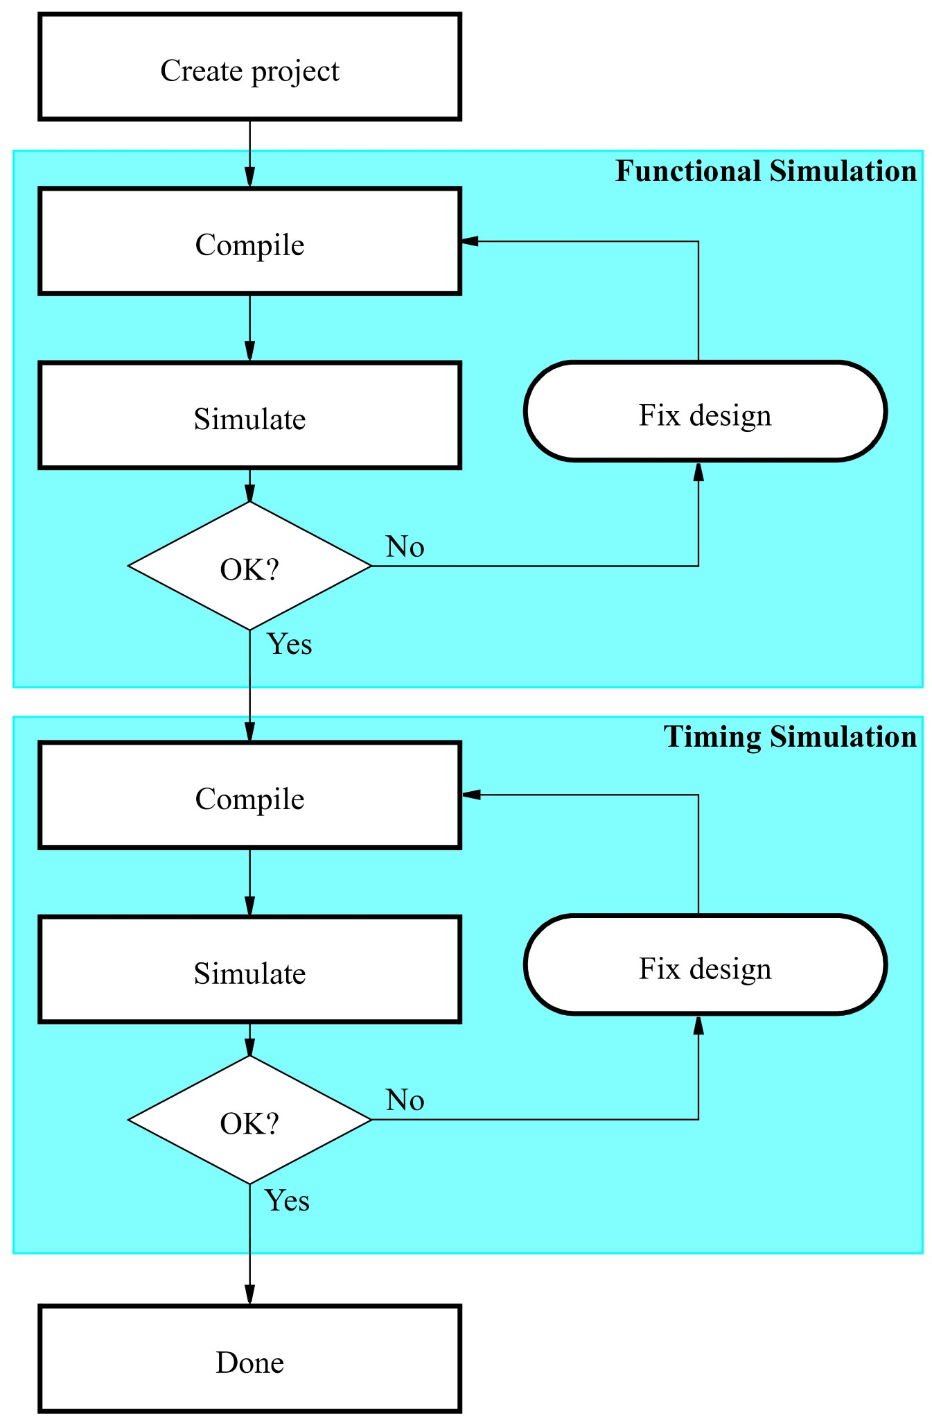

- Write a Verilog code for 8:1 multiplexer, simulate and verify it’s working

Aim: - To write a Verilog code for 8:1 multiplexer, simulate and verify it’s working.
Verilog Code :

module mux(en,a,y,sel);
input en;
input [7:0]a;
input [2:0]sel;
output y;
reg y;
always@(en or a or sel)
begin
if(en)
y=1'b0;
else case(sel)
3'b000:y=a[0];
3'b001:y=a[1];
3'b010:y=a[2];
3'b011:y=a[3];
3'b100:y=a[4];
3'b101:y=a[5];
3'b110:y=a[6];
3'b111:y=a[7];
default:y=1'b0;
endcase
end
endmodule

Observation:

Inference:

Lab Write-up and Execution rubrics (Max: 6 marks)
 |  |  | Excellent | Good | Poor | Marks
a. | Knowledge / Understanding  (2 Marks) |  | Demonstrates thorough ability in describing and illustrating the Verilog module  (2-1.5) | Demonstrates considerable ability in describing and illustrating the Verilog module  (1-0.5) | Unable to demonstrate, describe and illustrate the Verilog module  (0)
b. | Simulation of logic circuits  (2 Marks) |  | Exact simulation of logic circuit expressed  (2-1.5) | Required logic of the circuit expressed  (1-0.5) | Logic not properly expressed  (0)
c. | Circuit Data Recording  (2 Marks) |  | Correct data input and excellent presentation  (2-1.5) | Correct data input and fair presentation  (1-0.5) | Correct data input and poor presentation  (0)
Viva rubrics (Max: 4 marks)
 |  |  | Excellent | Good | Poor
a. |  | Circuit Data Analysis  (2 Marks) | Answers to data analysis questions, show complete understanding of how the module works  (2-1.5) | Answers to data analysis questions, show solid understanding of how the module works  (1) | Answers to data analysis questions, show no understanding of how the module works (0)
b. |  | Applications  (1 Mark) | Demonstrates high ability of the circuit  (1) | Demonstrates considerable ability of the logic circuit  (0.5) | Demonstrates very limited ability of the circuit  (0)
c. |  | Communication of Ideas  (1 Mark) | Communicates all ideas clearly (1) | Communicates limited ideas (0.5) | Unable to communicate ideas(0)
Staff Signature Total

- Write a Verilog code for a 4 bit comparator using logic gates, simulate and verify it’s working.

Aim: - To write a verilog/VHDL code for a 4 bit comparator using logic gates, simulate and verify it’s working.

Truth Table:
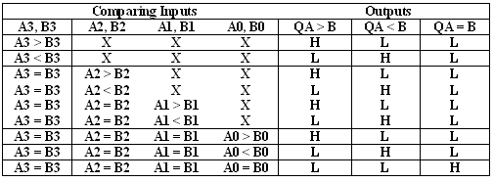
Verilog Code:

module comaprator(a,b,q1,q2,q3);
input[3:0] a,b;
output q1,q2,q3;
reg q1,q2,q3;
always@(a or b)
begin
if(a>b)
q1=1;
else
q1=0;
if(a<b)
q2=1;
else
q2=0;
if(a==b)
q3=1;
else
q3=0;
end

endmodule

Observation:

Inference:

Lab Write-up and Execution rubrics (Max: 6 marks)
 |  |  | Excellent | Good | Poor | Marks
a. | Knowledge / Understanding  (2 Marks) |  | Demonstrates thorough ability in describing and illustrating the Verilog module  (2-1.5) | Demonstrates considerable ability in describing and illustrating the Verilog module  (1-0.5) | Unable to demonstrate, describe and illustrate the Verilog module  (0)
b. | Simulation of logic circuits  (2 Marks) |  | Exact simulation of logic circuit expressed  (2-1.5) | Required logic of the circuit expressed  (1-0.5) | Logic not properly expressed  (0)
c. | Circuit Data Recording  (2 Marks) |  | Correct data input and excellent presentation  (2-1.5) | Correct data input and fair presentation  (1-0.5) | Correct data input and poor presentation  (0)
Viva rubrics (Max: 4 marks)
 |  |  | Excellent | Good | Poor
a. |  | Circuit Data Analysis  (2 Marks) | Answers to data analysis questions, show complete understanding of how the module works  (2-1.5) | Answers to data analysis questions, show solid understanding of how the module works  (1) | Answers to data analysis questions, show no understanding of how the module works (0)
b. |  | Applications  (1 Mark) | Demonstrates high ability of the circuit  (1) | Demonstrates considerable ability of the logic circuit  (0.5) | Demonstrates very limited ability of the circuit  (0)
c. |  | Communication of Ideas  (1 Mark) | Communicates all ideas clearly (1) | Communicates limited ideas (0.5) | Unable to communicate ideas(0)
Staff Signature Total

- Write a Verilog for D Flip-Flop with positive-edge triggering, simulate and verify it’s working.

Aim: - To write a Verilog code for D Flip-Flop with positive-edge triggering, simulate and verify its working.

Circuit Diagram

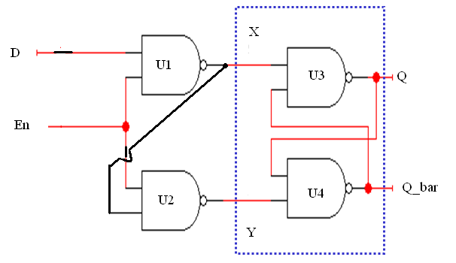
En | D | Qn | Qn+1 | State
1 | 0 | X | 0 | reset
1 | 1 | X | 1 | set
0 | X | X | Qn | No Change
Verilog Code:

module DFF(Q,Q_bar,D,En);
output Q, Q_bar;
input D, En;
wire X, Y;
nand U1 (X,D,En);
nand U2 (Y,X,En);
nand U3 (Q,Q_bar,X);
nand U4 (Q_bar,Q,Y);
endmodule

Observation:

Inference:

Lab Write-up and Execution rubrics (Max: 6 marks)
 |  |  | Excellent | Good | Poor | Marks
a. | Knowledge / Understanding  (2 Marks) |  | Demonstrates thorough ability in describing and illustrating the Verilog module  (2-1.5) | Demonstrates considerable ability in describing and illustrating the Verilog module  (1-0.5) | Unable to demonstrate, describe and illustrate the Verilog module  (0)
b. | Simulation of logic circuits  (2 Marks) |  | Exact simulation of logic circuit expressed  (2-1.5) | Required logic of the circuit expressed  (1-0.5) | Logic not properly expressed  (0)
c. | Circuit Data Recording  (2 Marks) |  | Correct data input and excellent presentation  (2-1.5) | Correct data input and fair presentation  (1-0.5) | Correct data input and poor presentation  (0)
Viva rubrics (Max: 4 marks)
 |  |  | Excellent | Good | Poor
a. |  | Circuit Data Analysis  (2 Marks) | Answers to data analysis questions, show complete understanding of how the module works  (2-1.5) | Answers to data analysis questions, show solid understanding of how the module works  (1) | Answers to data analysis questions, show no understanding of how the module works (0)
b. |  | Applications  (1 Mark) | Demonstrates high ability of the circuit  (1) | Demonstrates considerable ability of the logic circuit  (0.5) | Demonstrates very limited ability of the circuit  (0)
c. |  | Communication of Ideas  (1 Mark) | Communicates all ideas clearly (1) | Communicates limited ideas (0.5) | Unable to communicate ideas(0)
Staff Signature Total
- Write a Verilog code for a mod-N up counter, simulate and verify it’s working.
\
Aim: - To write a verilog/VHDL code for a mod-8 up counter, simulate and verify its working.

Verilog Code:

module upcounter(clk,rst,q);
input clk,rst;
output[2:0]q;
reg[2:0]q;

always@(posedge clk or posedge rst)
begin
if(rst==1)
q<=3'b000;
else
q<=q+1;
end
endmodule

Observation:

Inference:

Lab Write-up and Execution rubrics (Max: 6 marks)
 |  |  | Excellent | Good | Poor | Marks
a. | Knowledge / Understanding  (2 Marks) |  | Demonstrates thorough ability in describing and illustrating the Verilog module  (2-1.5) | Demonstrates considerable ability in describing and illustrating the Verilog module  (1-0.5) | Unable to demonstrate, describe and illustrate the Verilog module  (0)
b. | Simulation of logic circuits  (2 Marks) |  | Exact simulation of logic circuit expressed  (2-1.5) | Required logic of the circuit expressed  (1-0.5) | Logic not properly expressed  (0)
c. | Circuit Data Recording  (2 Marks) |  | Correct data input and excellent presentation  (2-1.5) | Correct data input and fair presentation  (1-0.5) | Correct data input and poor presentation  (0)
Viva rubrics (Max: 4 marks)
 |  |  | Excellent | Good | Poor
a. |  | Circuit Data Analysis  (2 Marks) | Answers to data analysis questions, show complete understanding of how the module works  (2-1.5) | Answers to data analysis questions, show solid understanding of how the module works  (1) | Answers to data analysis questions, show no understanding of how the module works (0)
b. |  | Applications  (1 Mark) | Demonstrates high ability of the circuit  (1) | Demonstrates considerable ability of the logic circuit  (0.5) | Demonstrates very limited ability of the circuit  (0)
c. |  | Communication of Ideas  (1 Mark) | Communicates all ideas clearly (1) | Communicates limited ideas (0.5) | Unable to communicate ideas(0)
Staff Signature Total

- Write a Verilog code for Mod-N Synchronous up-counter. Simulate and verify its truth table.

Aim:Write a verilog code for modulo-3 counter. Simulate and verify its truth table .

Verilog Code:

module mod3 (clk,rst,q);
input clk,rst;
output[1:0]q;
reg[1:0]q;

always@(posedge clk)
begin
if(~rst)
begin
if(q==2’b10) begin
q<=2’b00;
end
else begin
q<=q+1;
end
end
end
endmodule

Observation:

Inference:

Lab Write-up and Execution rubrics (Max: 6 marks)
 |  |  | Excellent | Good | Poor | Marks
a. | Knowledge / Understanding  (2 Marks) |  | Demonstrates thorough ability in describing and illustrating the Verilog module  (2-1.5) | Demonstrates considerable ability in describing and illustrating the Verilog module  (1-0.5) | Unable to demonstrate, describe and illustrate the Verilog module  (0)
b. | Simulation of logic circuits  (2 Marks) |  | Exact simulation of logic circuit expressed  (2-1.5) | Required logic of the circuit expressed  (1-0.5) | Logic not properly expressed  (0)
c. | Circuit Data Recording  (2 Marks) |  | Correct data input and excellent presentation  (2-1.5) | Correct data input and fair presentation  (1-0.5) | Correct data input and poor presentation  (0)
Viva rubrics (Max: 4 marks)
 |  |  | Excellent | Good | Poor
a. |  | Circuit Data Analysis  (2 Marks) | Answers to data analysis questions, show complete understanding of how the module works  (2-1.5) | Answers to data analysis questions, show solid understanding of how the module works  (1) | Answers to data analysis questions, show no understanding of how the module works (0)
b. |  | Applications  (1 Mark) | Demonstrates high ability of the circuit  (1) | Demonstrates considerable ability of the logic circuit  (0.5) | Demonstrates very limited ability of the circuit  (0)
c. |  | Communication of Ideas  (1 Mark) | Communicates all ideas clearly (1) | Communicates limited ideas (0.5) | Unable to communicate ideas(0)
Staff Signature Total

- Write the Verilog description code for the given mealy model.

Aim: To write the Verilog description code for the given mealy model.

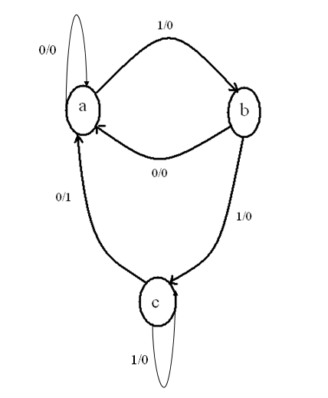
Verilog code:

module mealyfsm (x, clk, rst,y);
input x,clk,rst;
output y;
reg y;
reg [1:0] ps, ns;
parameter a=2’b00, b=2’b01, c=2’b10;
always @ (negedge clk or negedge rst)
if(~rst) ps=a;
else
ps=ns;
always @ (ps or x)
if(ps==a && x==0) ns=a;
else if (pa==a && x==1) ns =b;
else if (ps==b && x==0) ns=a;
else if (ps==b && x==1) ns=c;
else if (ps==c && x==0) ns=a;
else if (ps==c && x==1) ns=c;
always @ (ps or x)
if (ps==c && x==0) y=1;
else
y=0;

endmodule

Observation:

Inference:

Lab Write-up and Execution rubrics (Max: 6 marks)
 |  |  | Excellent | Good | Poor | Marks
a. | Knowledge / Understanding  (2 Marks) |  | Demonstrates thorough ability in describing and illustrating the Verilog module  (2-1.5) | Demonstrates considerable ability in describing and illustrating the Verilog module  (1-0.5) | Unable to demonstrate, describe and illustrate the Verilog module  (0)
b. | Simulation of logic circuits  (2 Marks) |  | Exact simulation of logic circuit expressed  (2-1.5) | Required logic of the circuit expressed  (1-0.5) | Logic not properly expressed  (0)
c. | Circuit Data Recording  (2 Marks) |  | Correct data input and excellent presentation  (2-1.5) | Correct data input and fair presentation  (1-0.5) | Correct data input and poor presentation  (0)
Viva rubrics (Max: 4 marks)
 |  |  | Excellent | Good | Poor
a. |  | Circuit Data Analysis  (2 Marks) | Answers to data analysis questions, show complete understanding of how the module works  (2-1.5) | Answers to data analysis questions, show solid understanding of how the module works  (1) | Answers to data analysis questions, show no understanding of how the module works (0)
b. |  | Applications  (1 Mark) | Demonstrates high ability of the circuit  (1) | Demonstrates considerable ability of the logic circuit  (0.5) | Demonstrates very limited ability of the circuit  (0)
c. |  | Communication of Ideas  (1 Mark) | Communicates all ideas clearly (1) | Communicates limited ideas (0.5) | Unable to communicate ideas(0)
Staff Signature Total

